Lancaster Seventh-Day Adventist Church
A House of Prayer for All People

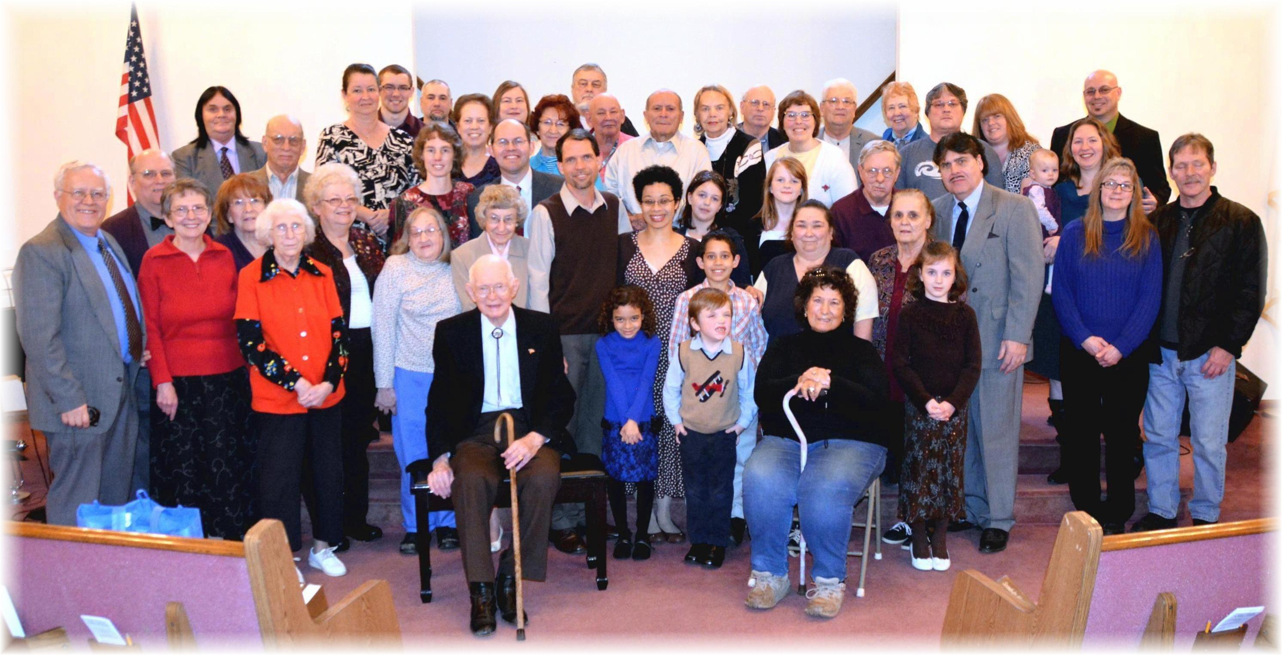
The Dean’s Farewell
February 27, 2016

