Lancaster Seventh-Day Adventist Church
A House of Prayer for All People

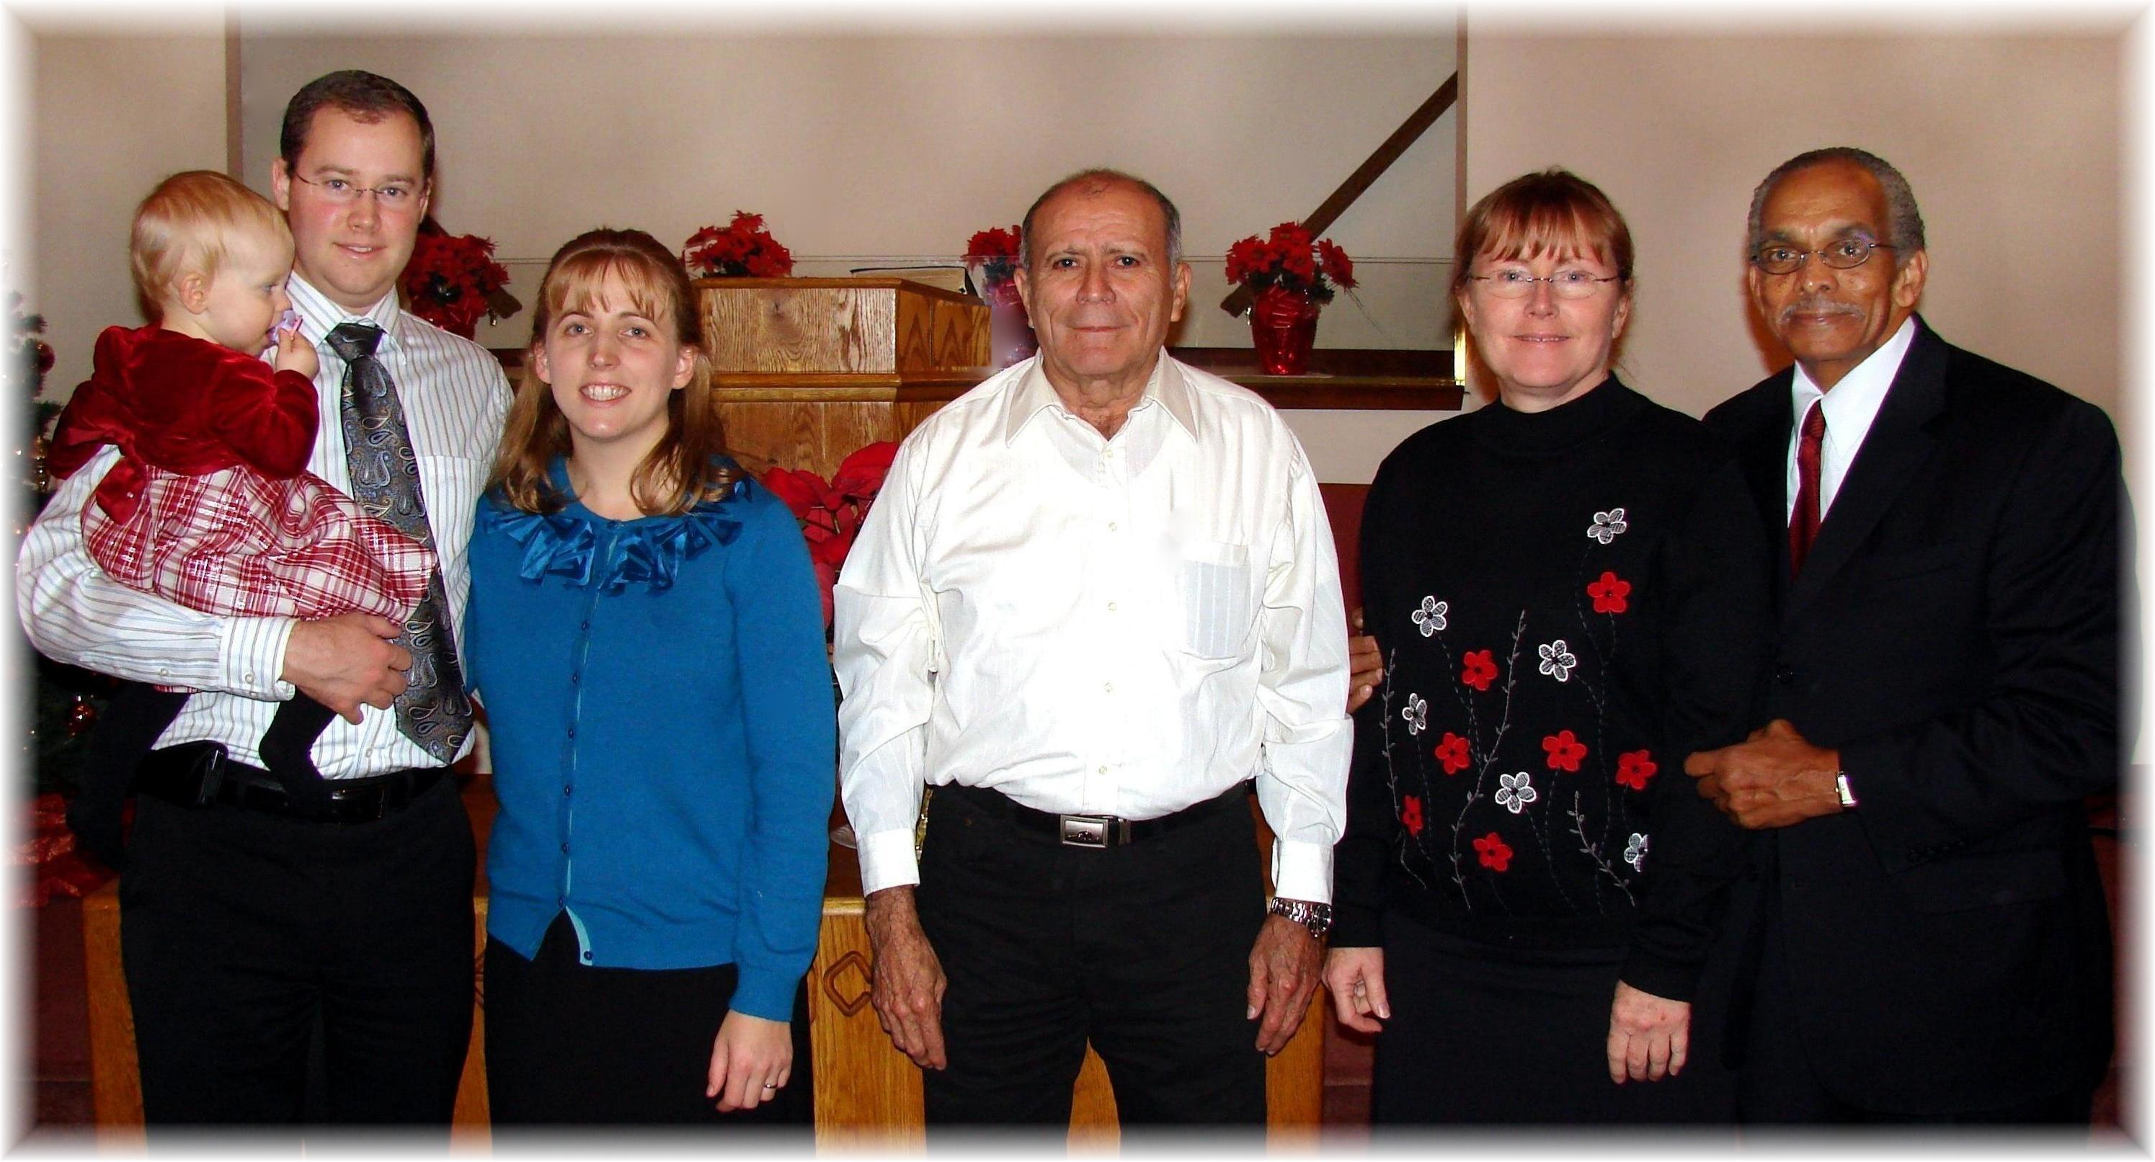
Joel & Marijke Schlittenhart (with Chloe), Fidel Rodriquez, Chris & Rick Wise
Our Newest Members – December 3, 2011

