Lancaster
Seventh-Day Adventist Church
A House of Prayer for All People

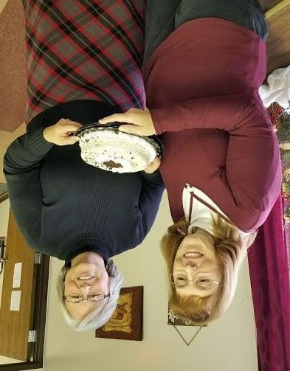
Carol and Debbie
January Birthdays - 2018

