Lancaster Seventh-Day Adventist Church
A House of Prayer for All People

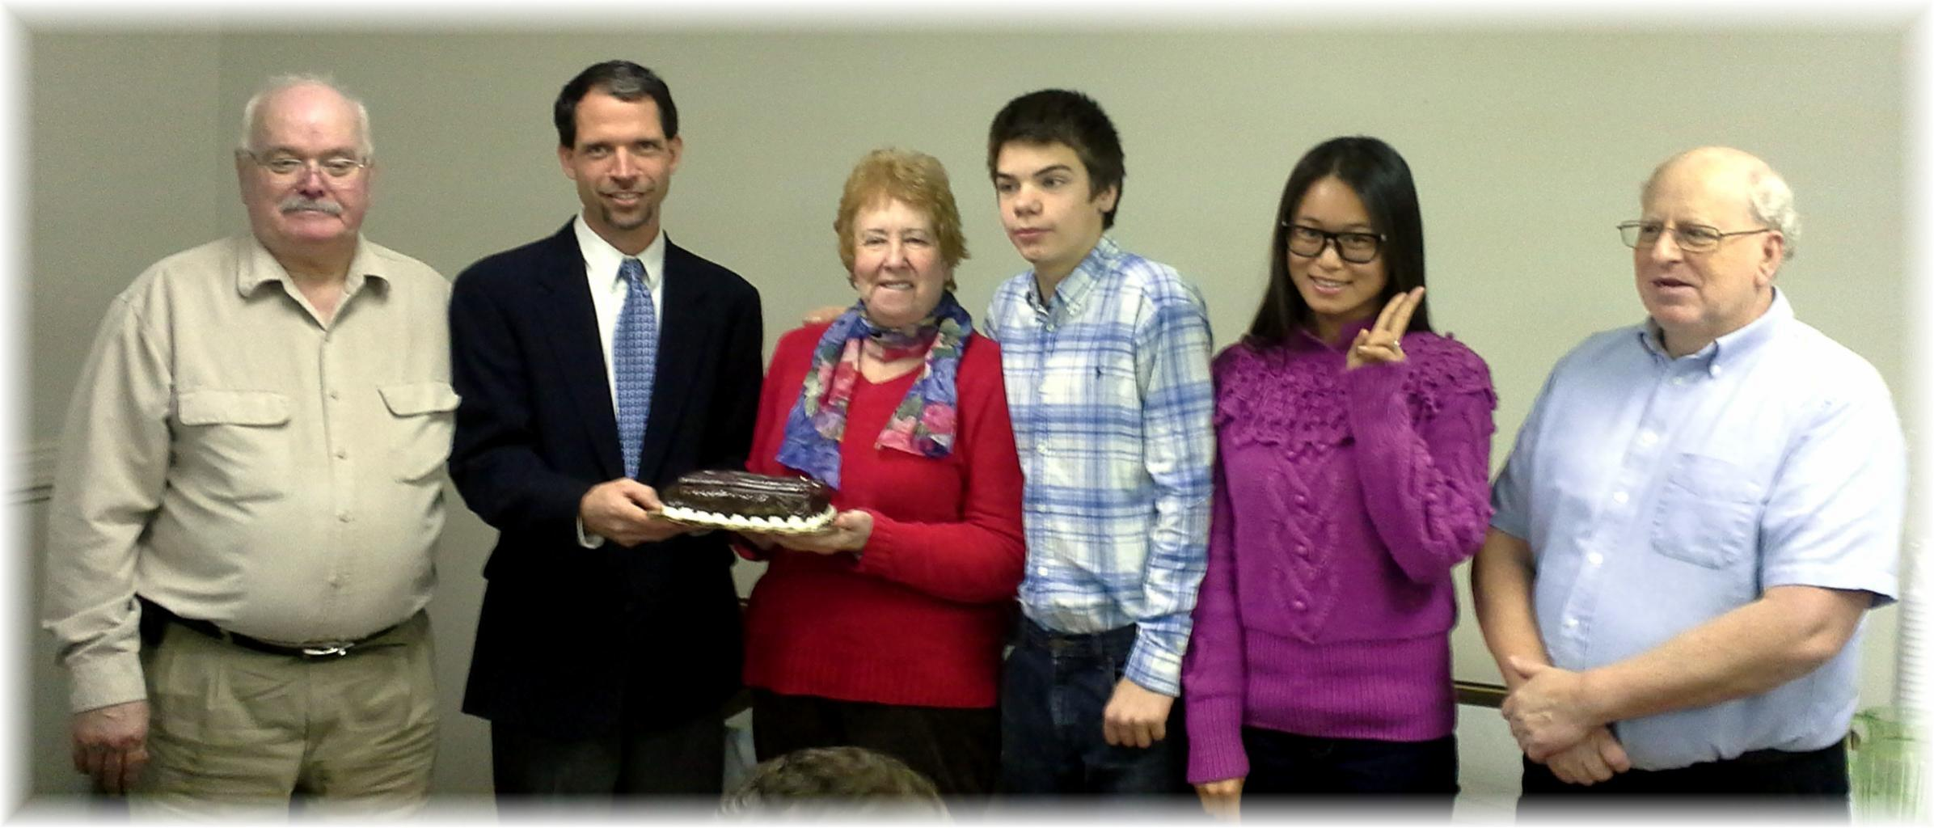
Birthdays: Darrell, Travis, Huiling, Bill
Anniversary: Diane - in the middle (with Jacob)
December Birthdays and Anniversary - 2014

