Lancaster Seventh-Day Adventist Church
A House of Prayer for All People

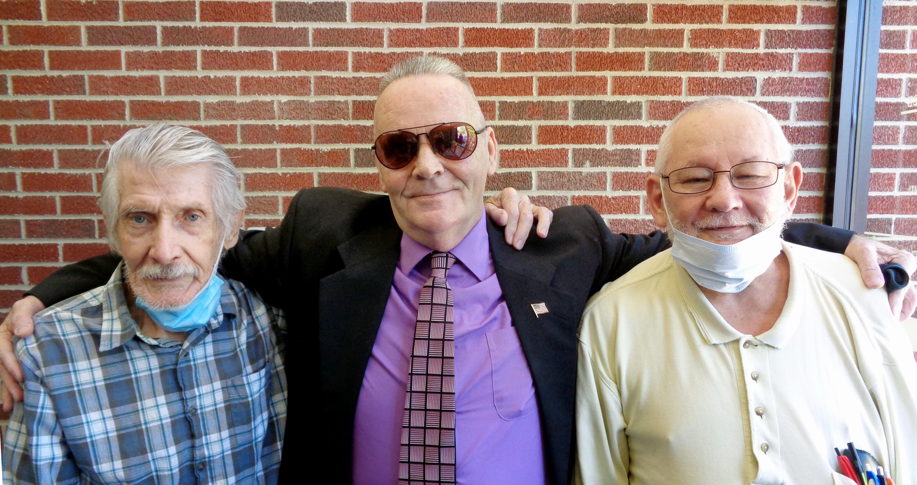
George George George
September ~~ 2020

