Lancaster Seventh-Day Adventist Church
A House of Prayer for All People

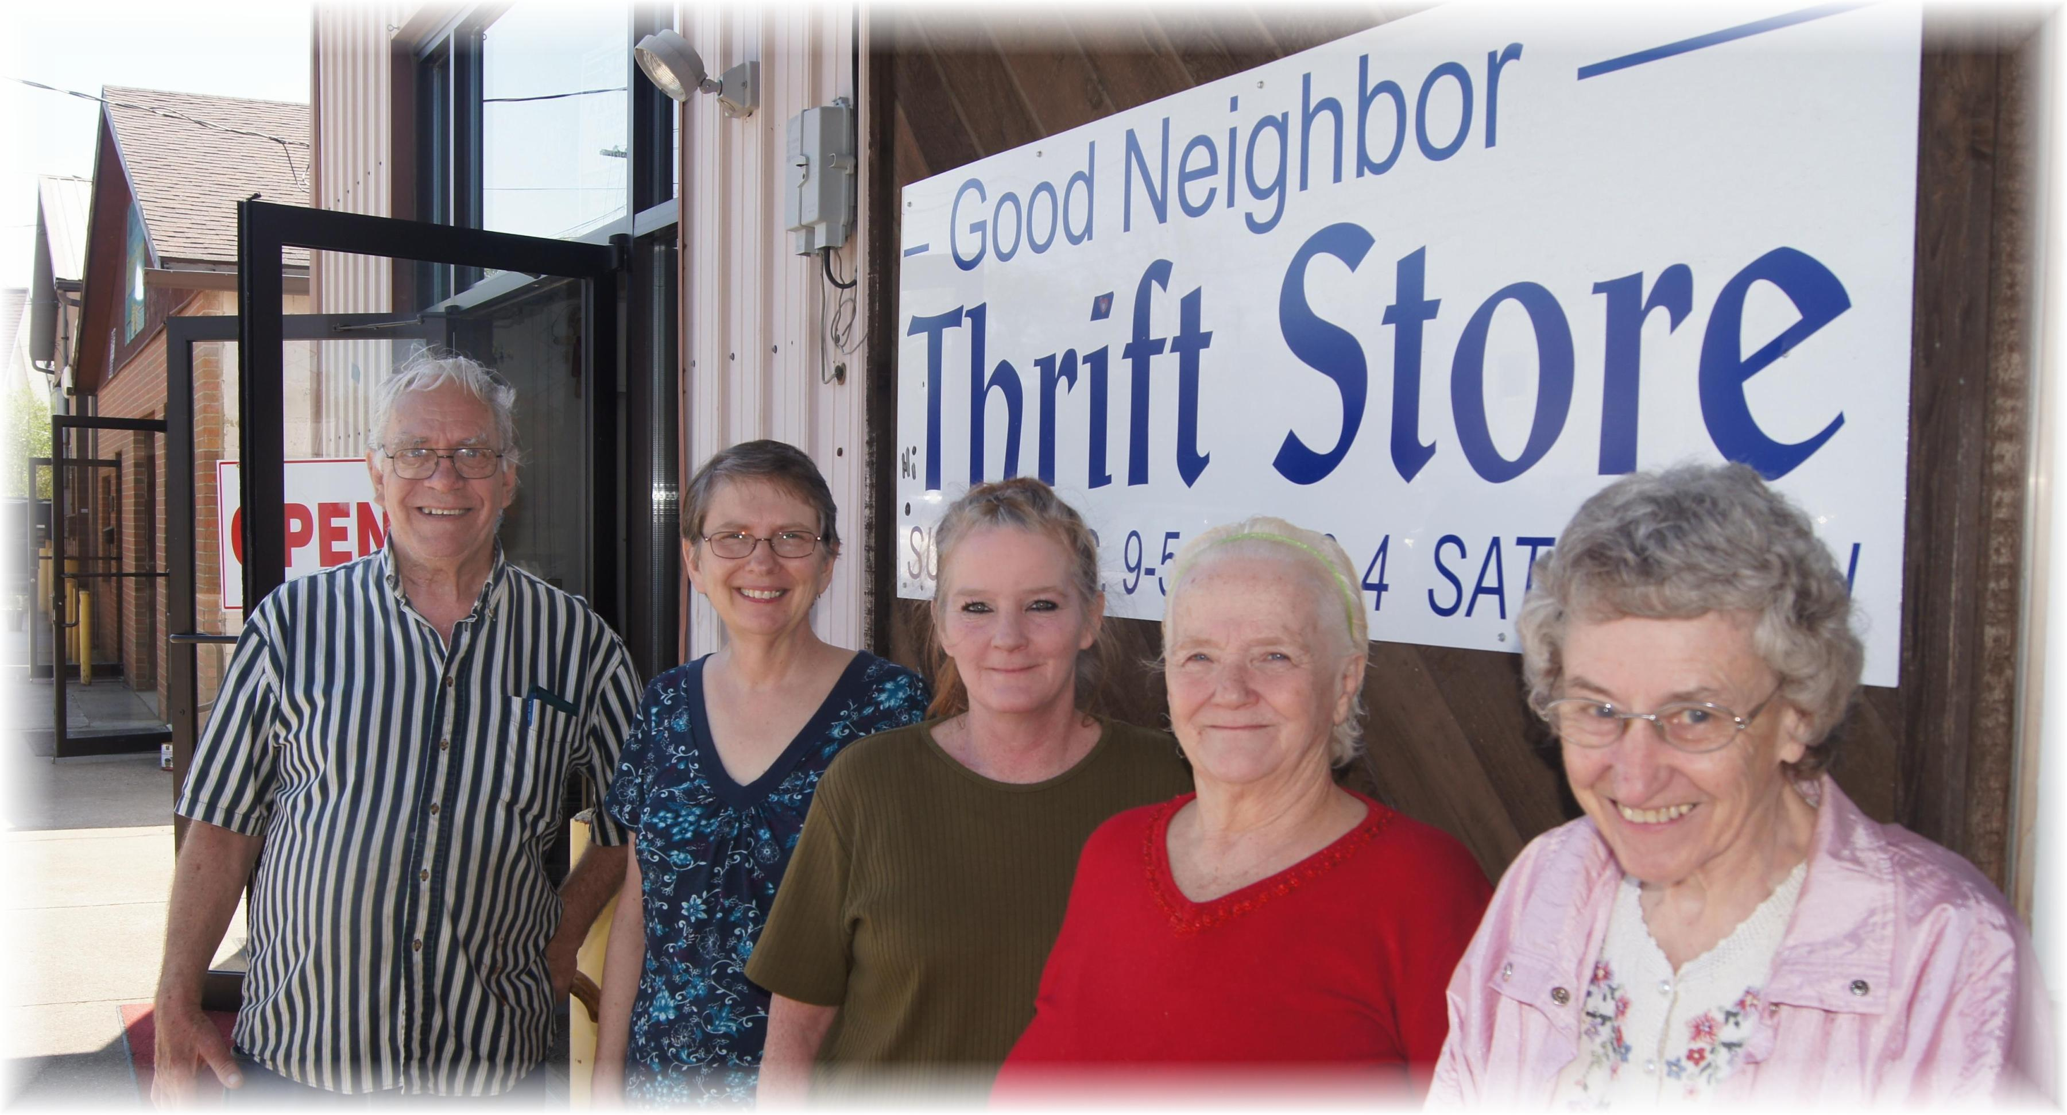
Tom, Bonnie, Lori, Sandy, Freda
Good Neighbor Thrift Store – 5th Anniversary – May1, 2013

