Lancaster Seventh-Day Adventist Church
A House of Prayer for All People

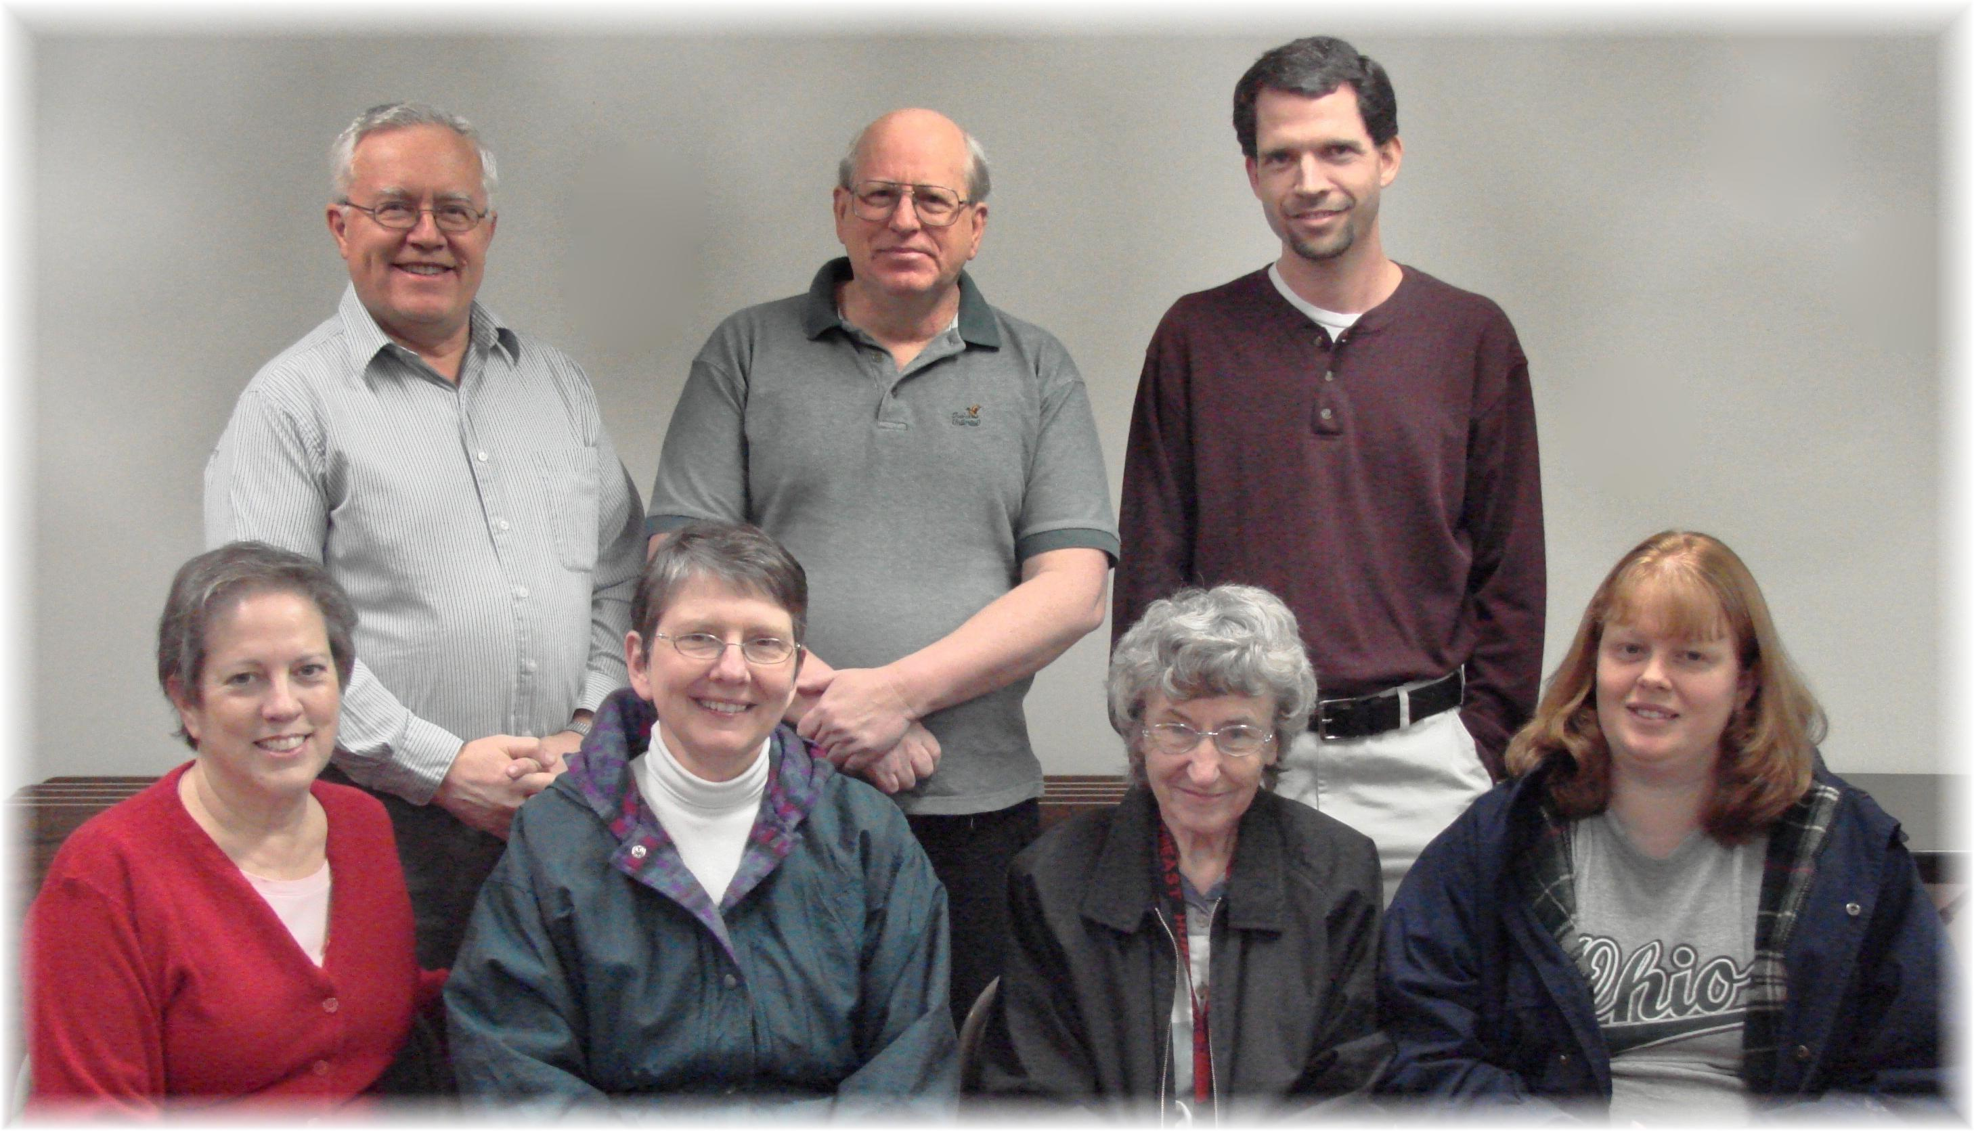
Geri, Al, Bonnie, Bill, Freda, Pastor Travis, Tammy
Lancaster S.D.A. School Board - 2010

