Lancaster Seventh-Day Adventist Church
A House of Prayer for All People

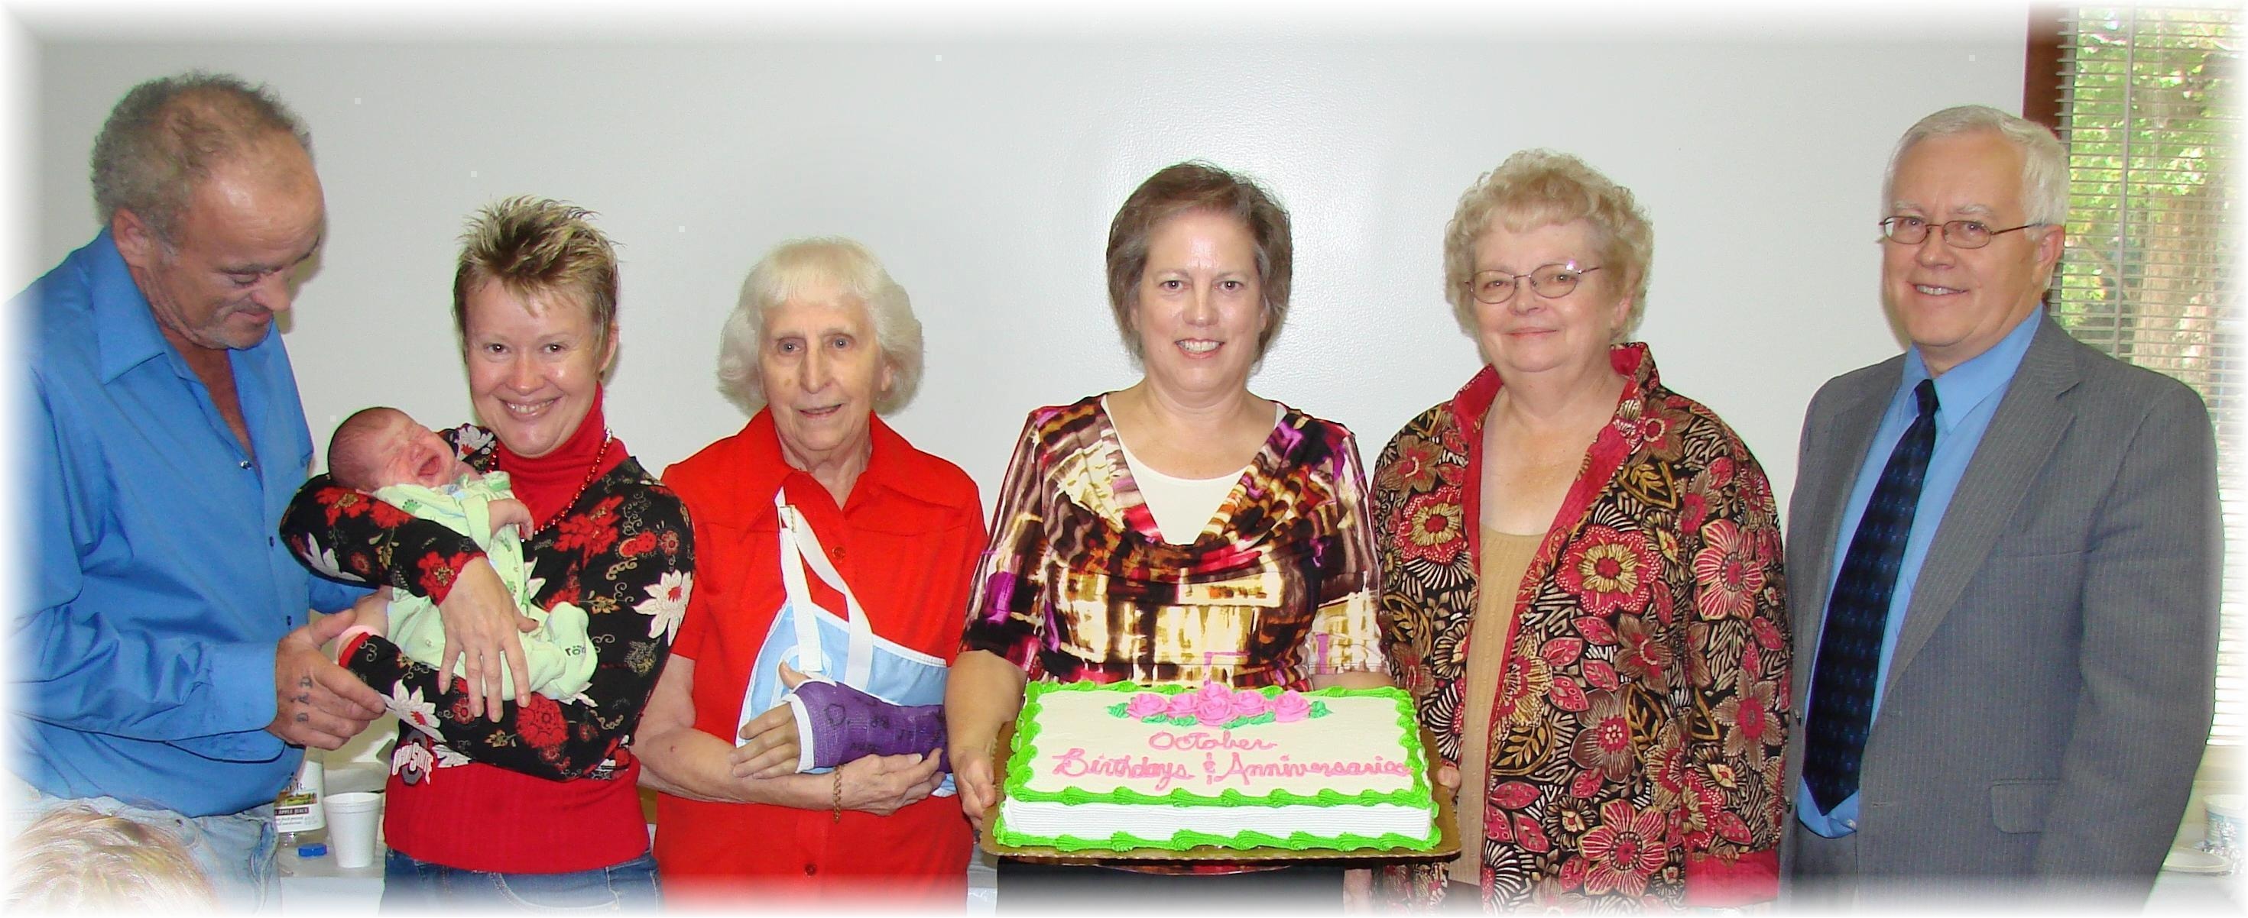
Birthdays: Allen and Dena with Jimmy, Edith, Geri, Sandy, Al
October Birthdays - 2010

