Lancaster Seventh-Day Adventist Church
A House of Prayer for All People

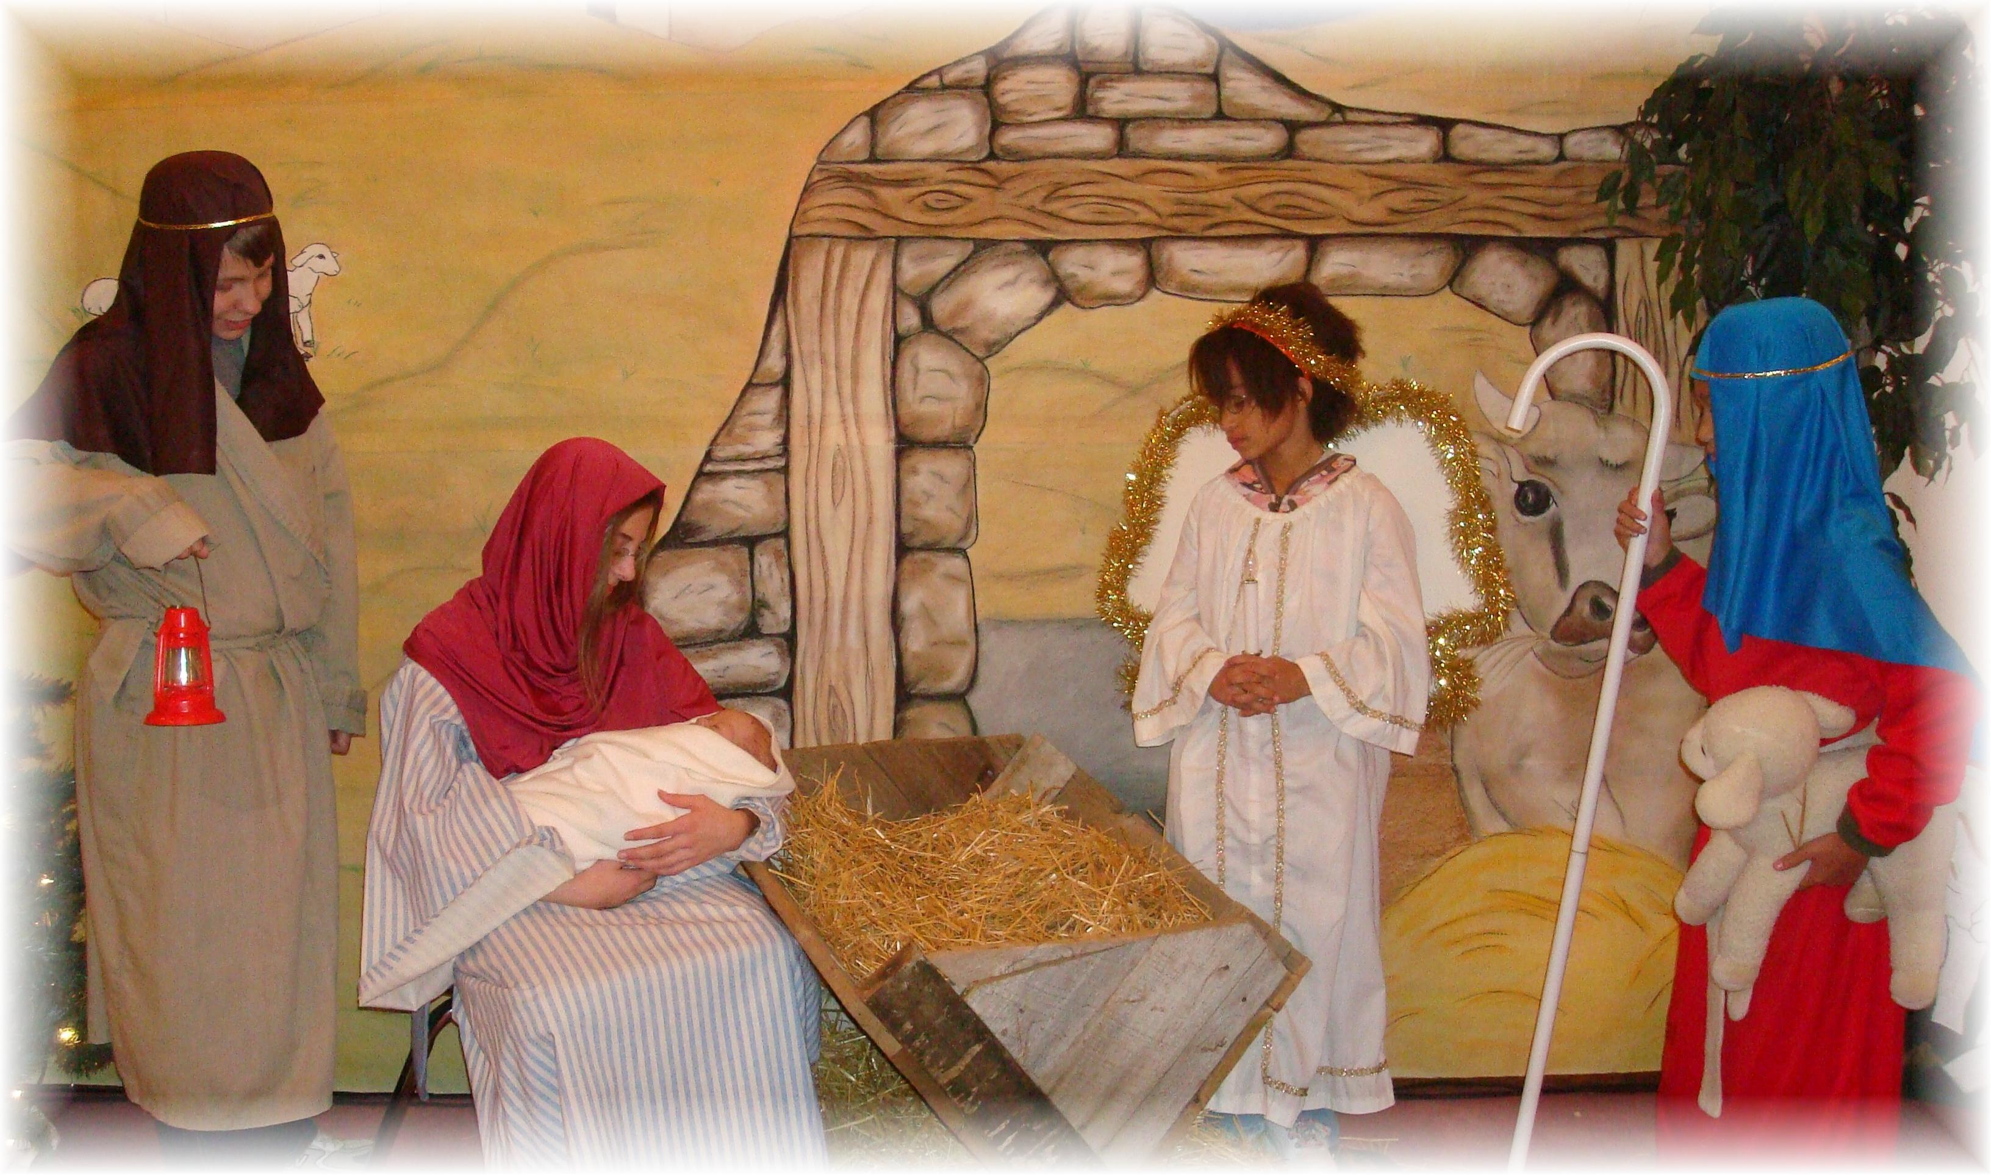
Church School Christmas Program - December 11, 2010

