Lancaster Seventh-Day Adventist Church
A House of Prayer for All People

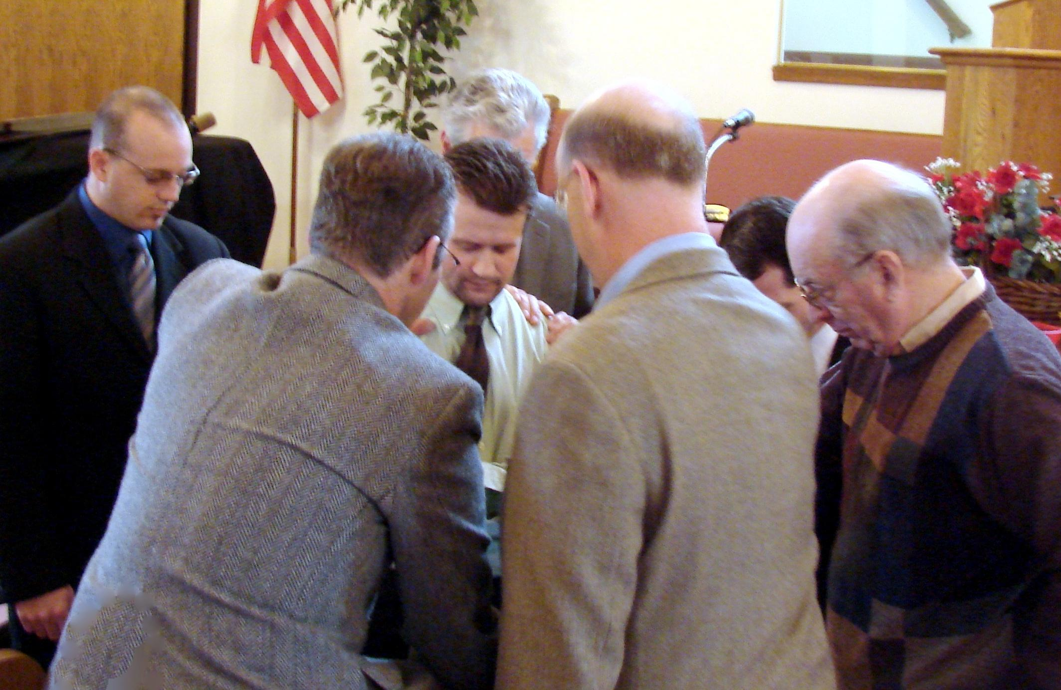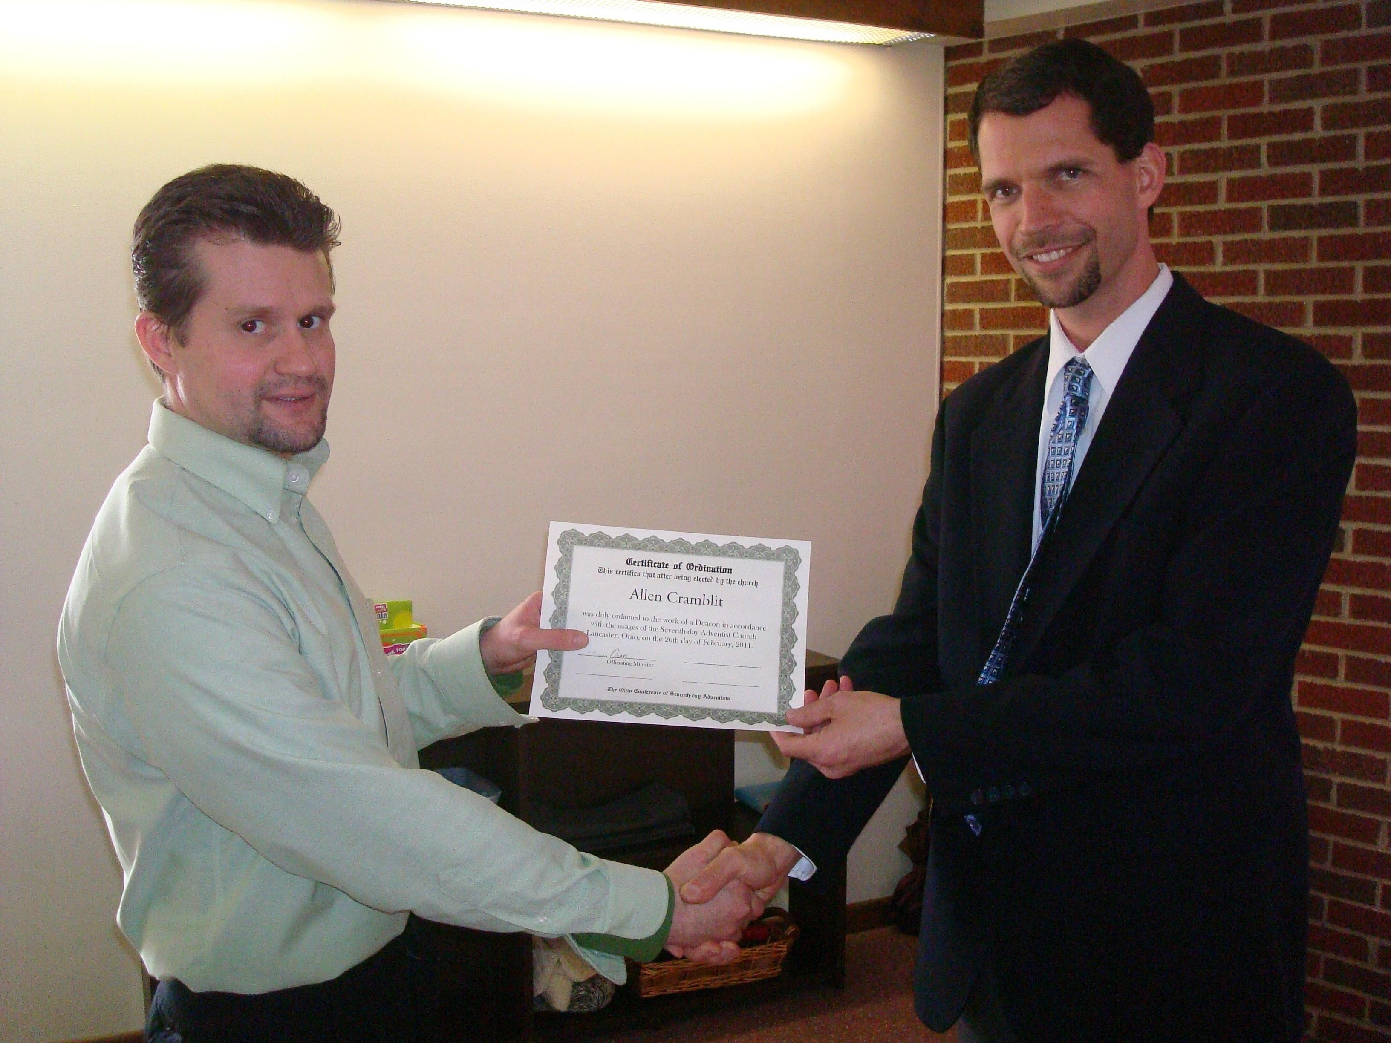

Allen Cramblit - Deacon Ordination - February 26, 2011

