Lancaster Seventh-Day Adventist Church
A House of Prayer for All People

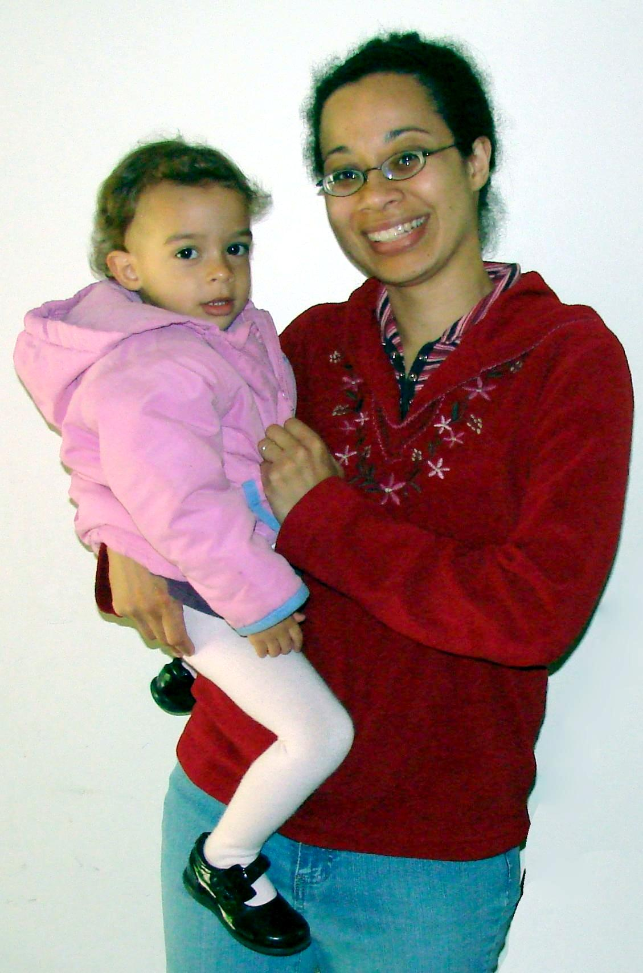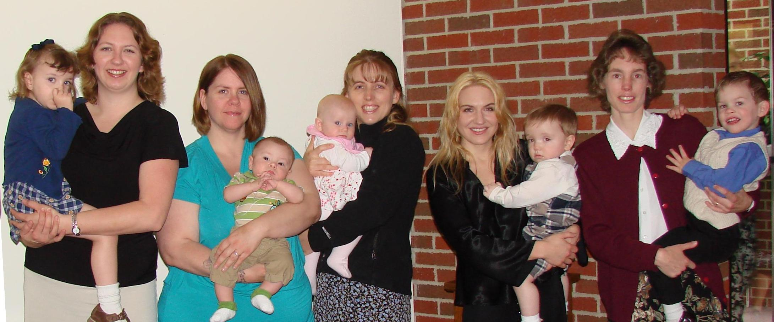
Happy Mother’s Day -- 2011

