Lancaster Seventh-Day Adventist Church
A House of Prayer for All People

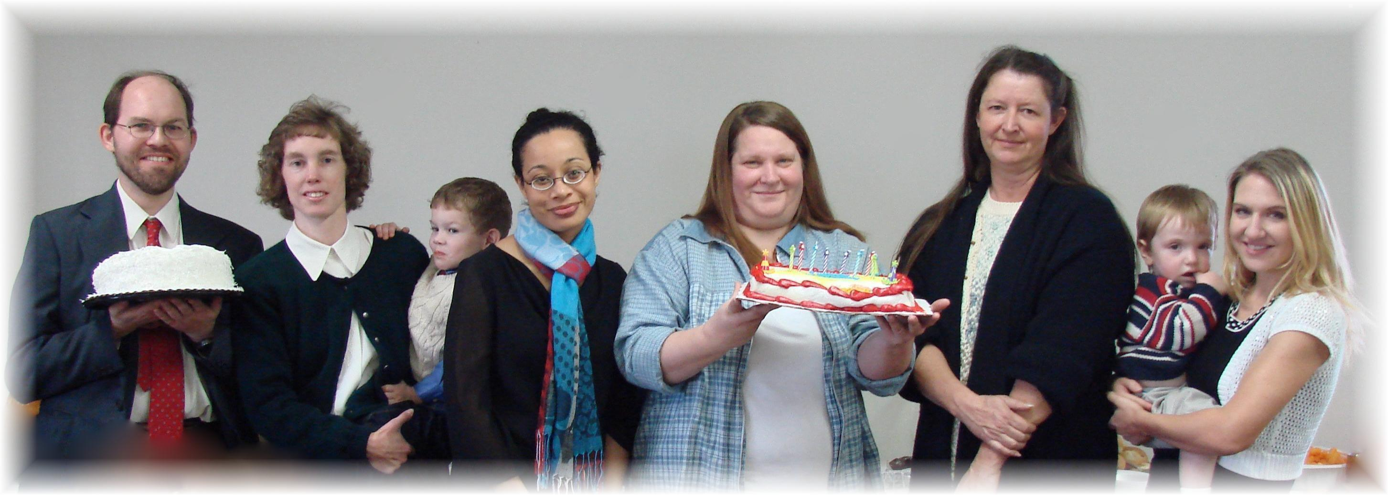

Anniversary: James & Connie (with Andrew) Birthdays: Cesilia, Twila, Cyndee, Jesse (with Trina)
November Anniversary and Birthdays - 2011

