Lancaster Seventh-Day Adventist Church
A House of Prayer for All People

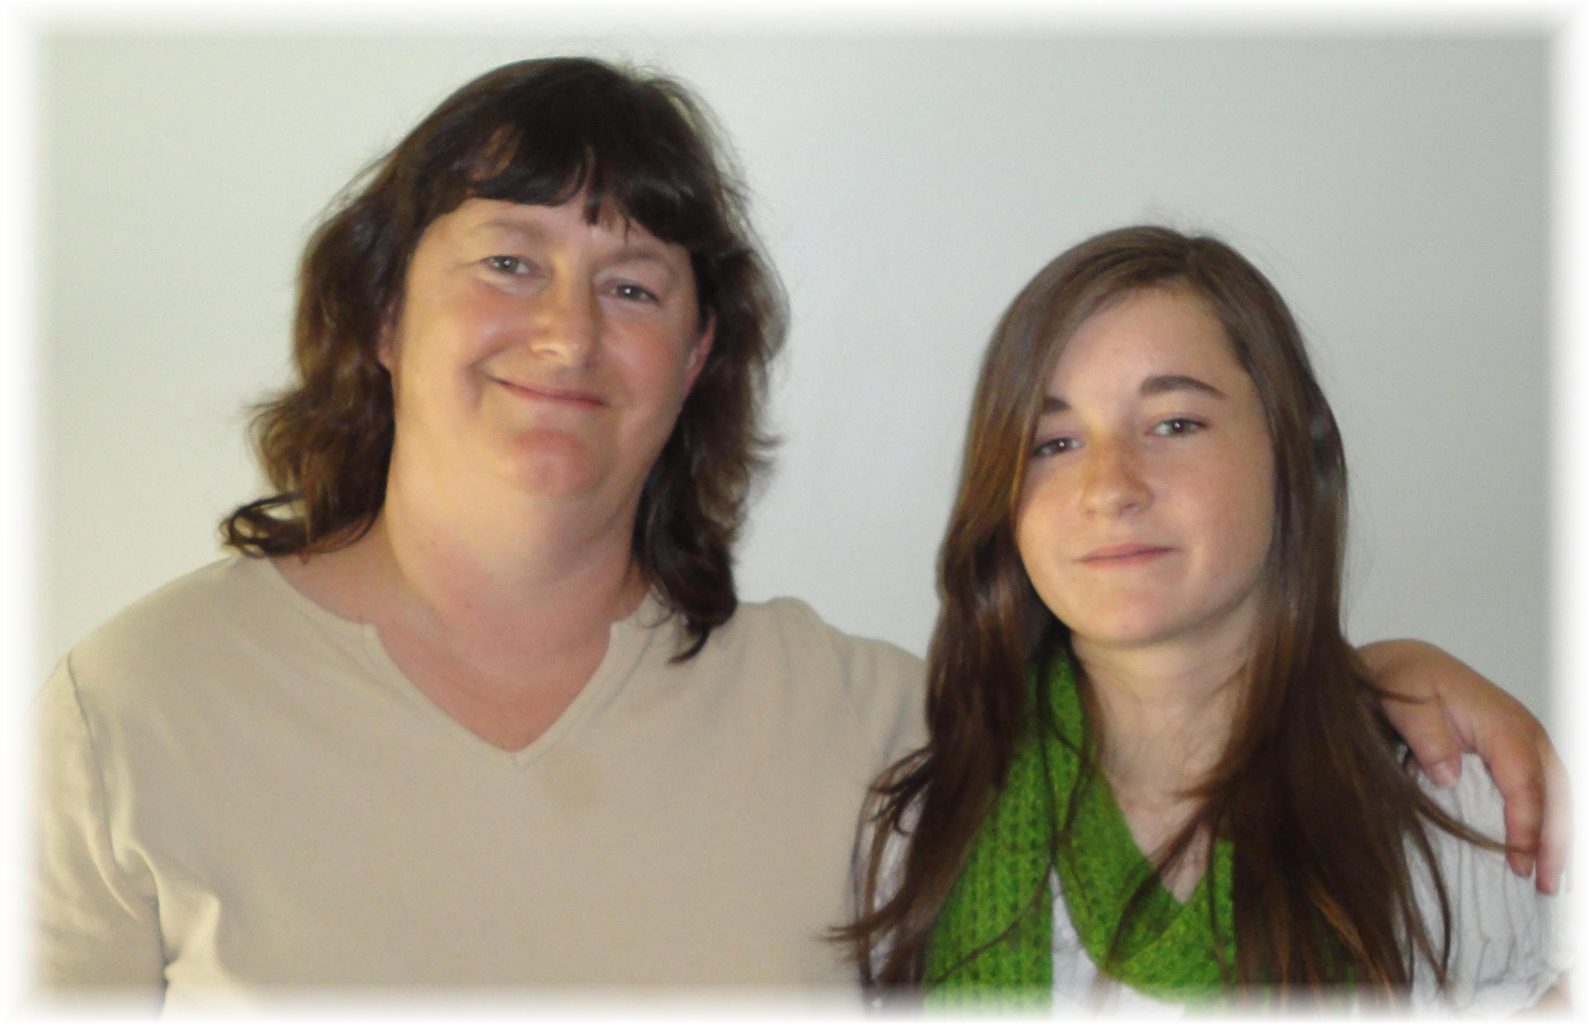
Kim Clarke and Emily Baldwin
Our Newest Members – February 25, 2012

