Lancaster Seventh-Day Adventist Church
A House of Prayer for All People
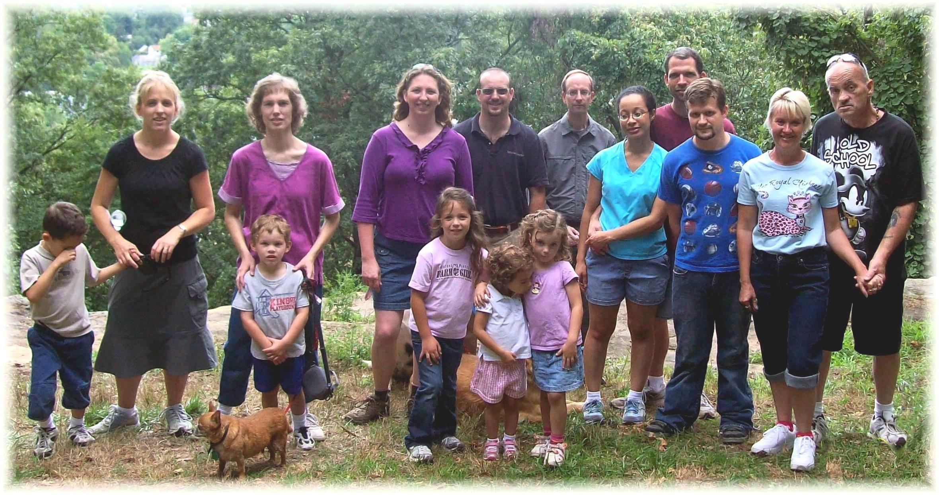
Health Hike at Keller-Kirn Nature Park – August 18, 2012

