Lancaster Seventh-Day Adventist Church
A House of Prayer for All People

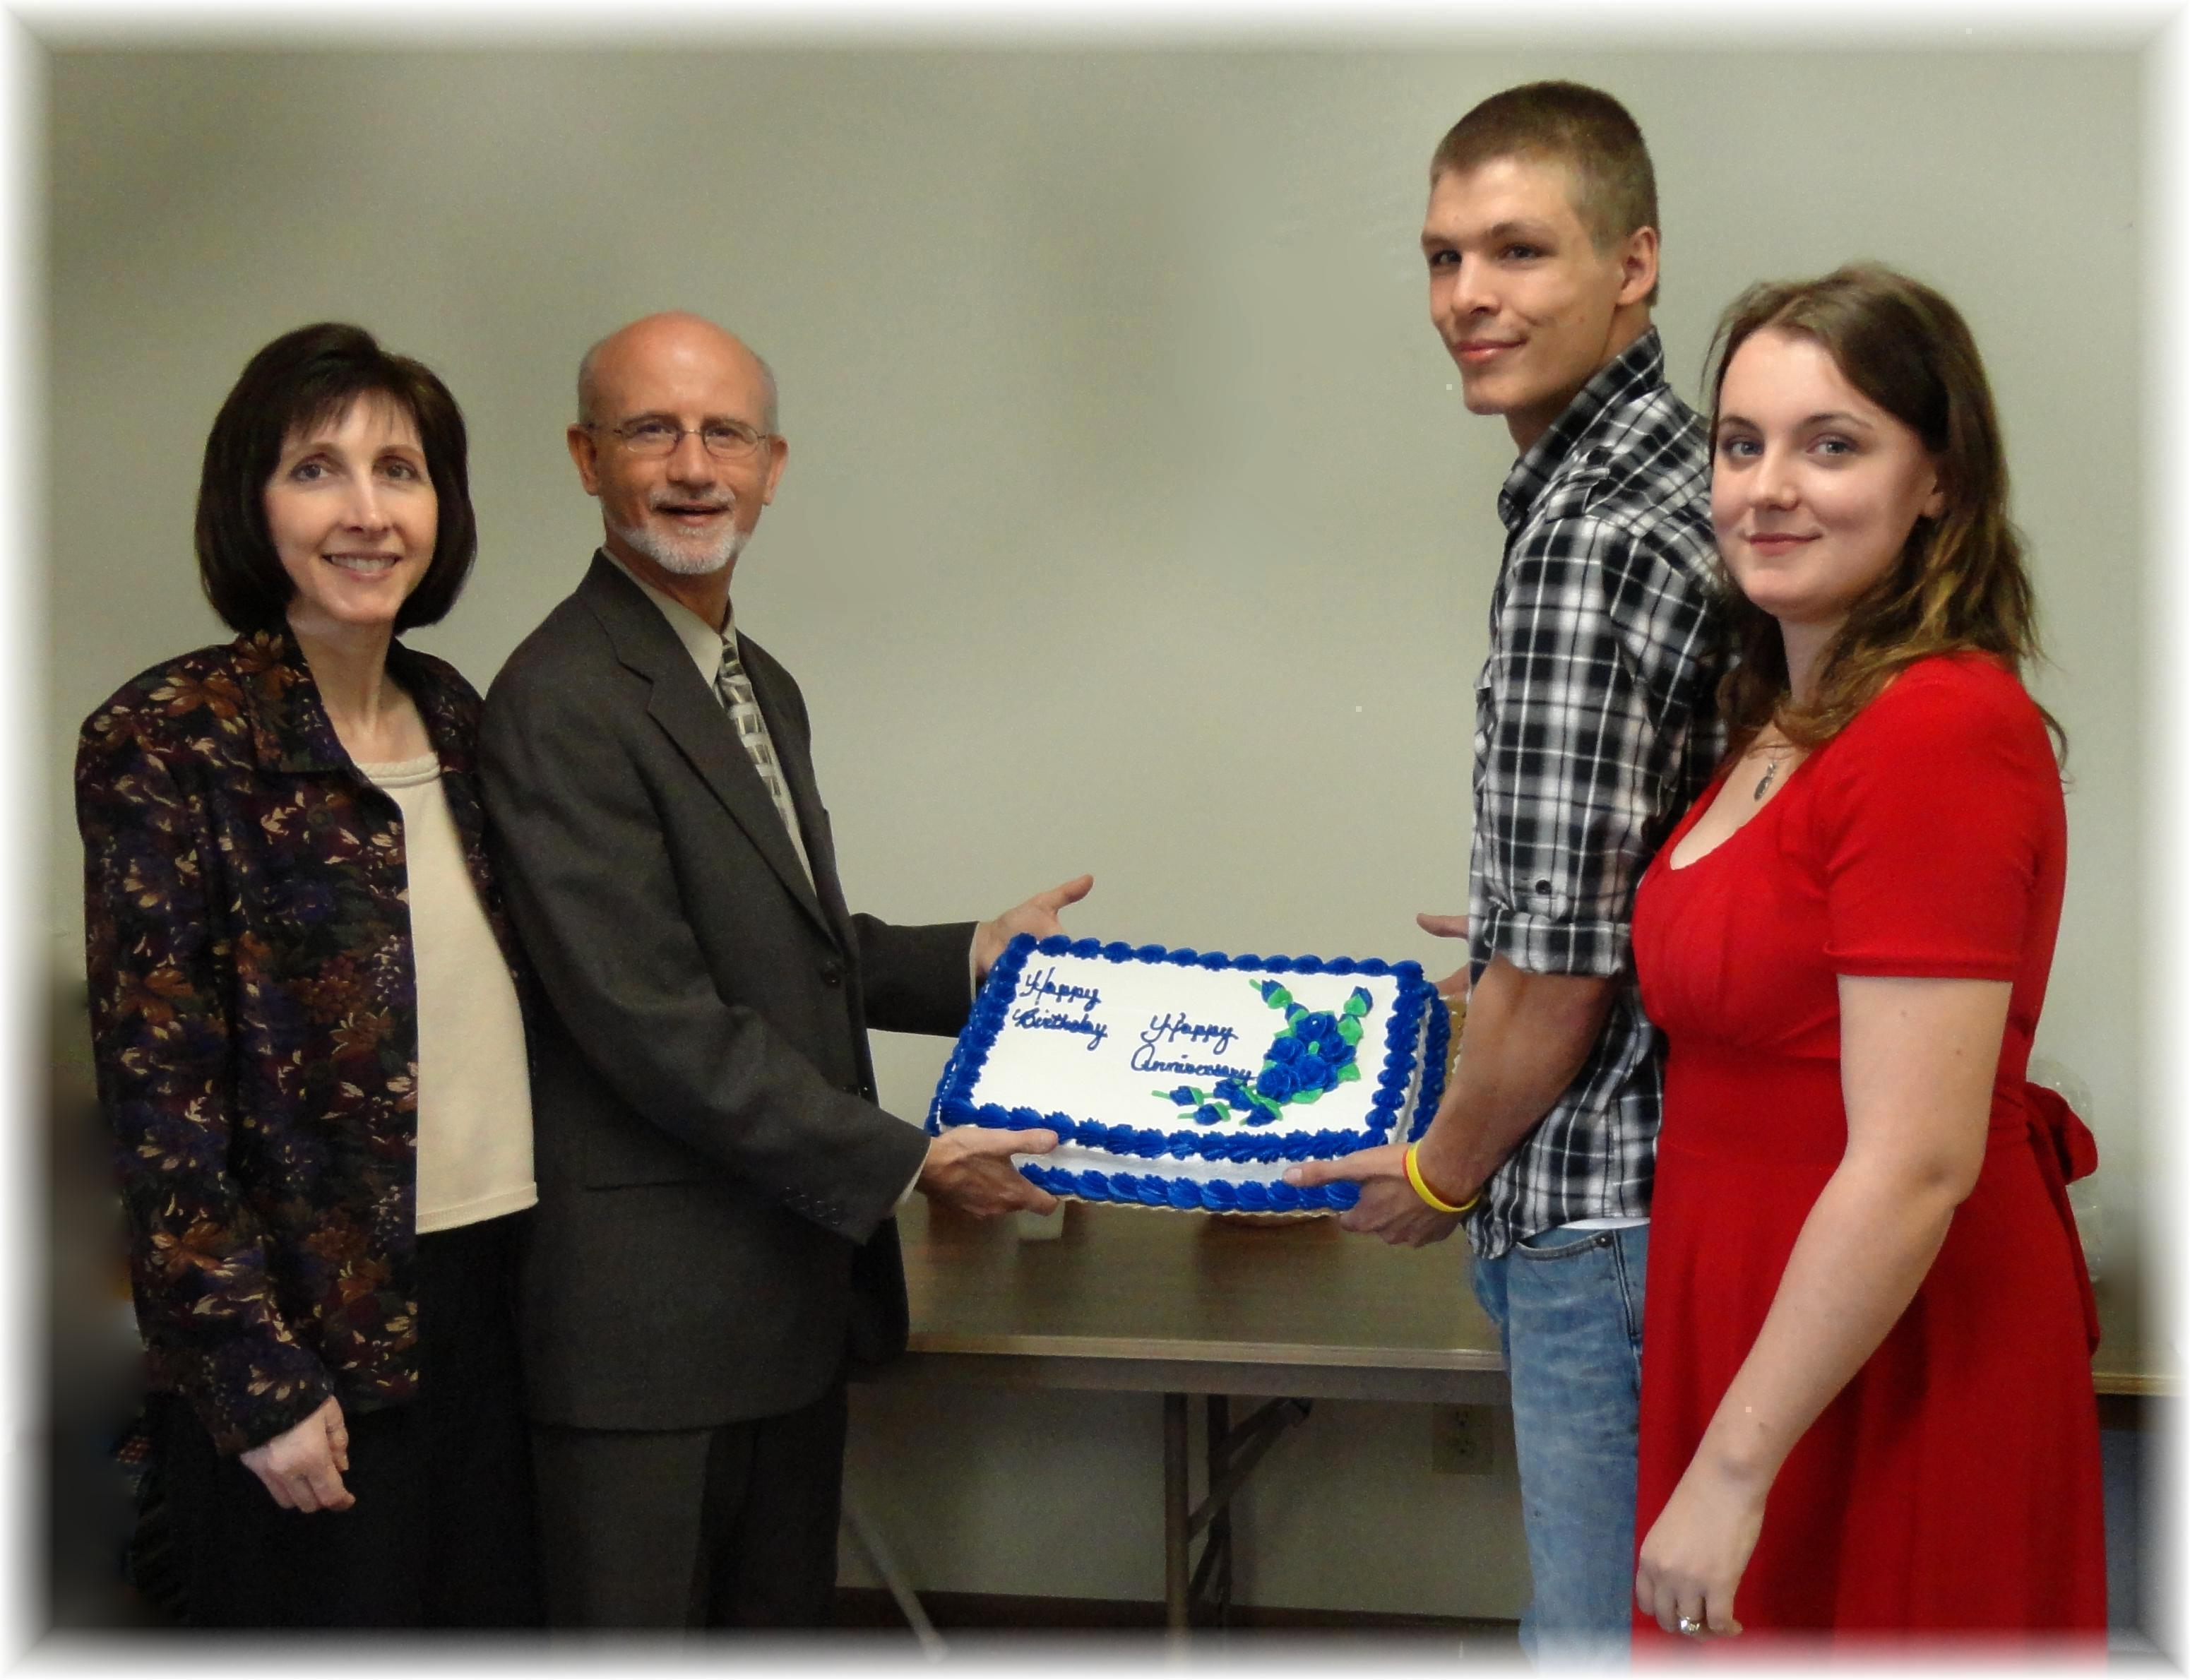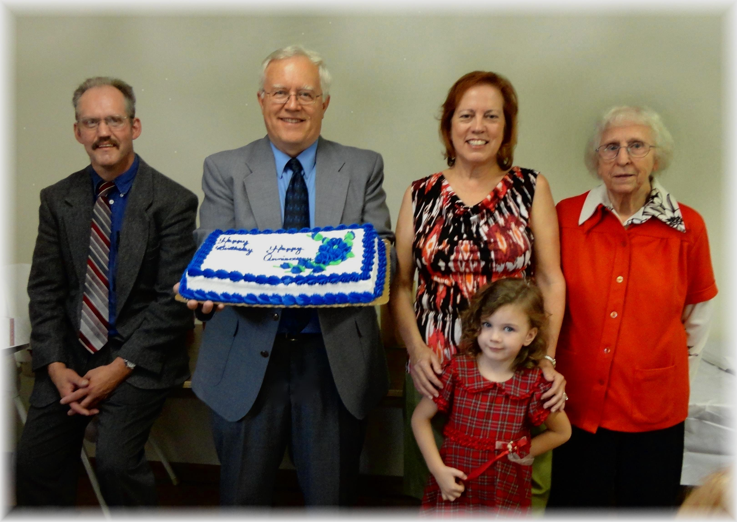
Anniversaries: Nancy & Mike, Seth & Shaina Birthdays: Andy, Al, Geri, Alena, Edith
October Anniversaries and Birthdays - 2012

