Lancaster Seventh-Day Adventist Church
A House of Prayer for All People

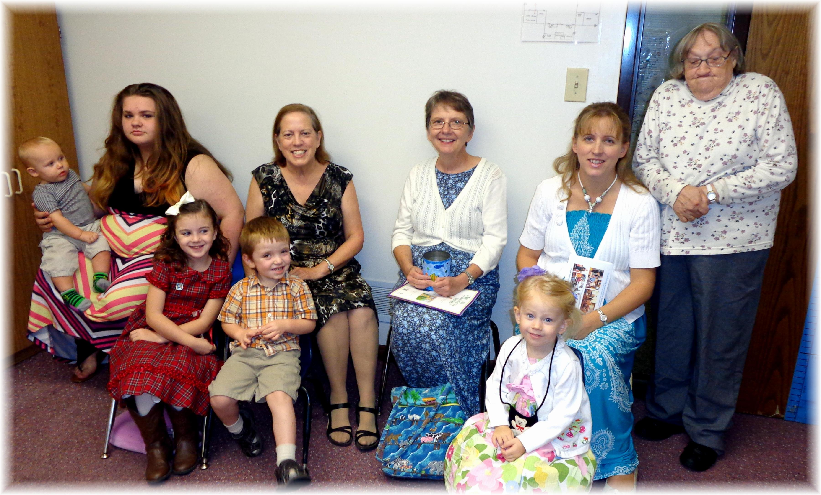
Cradle Roll – Kindergarten Sabbath School - 2013

