Lancaster Seventh-Day Adventist Church
A House of Prayer for All People
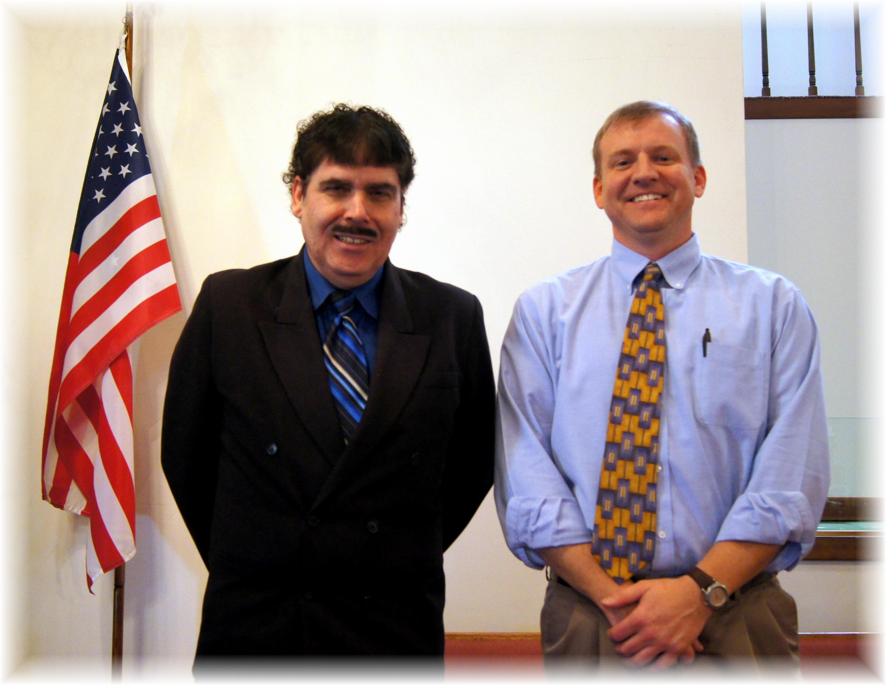
Thank you for your service: Carlton DeNune, Jim Wright
Veterans Day – November 2013

