Lancaster Seventh-Day Adventist Church
A House of Prayer for All People

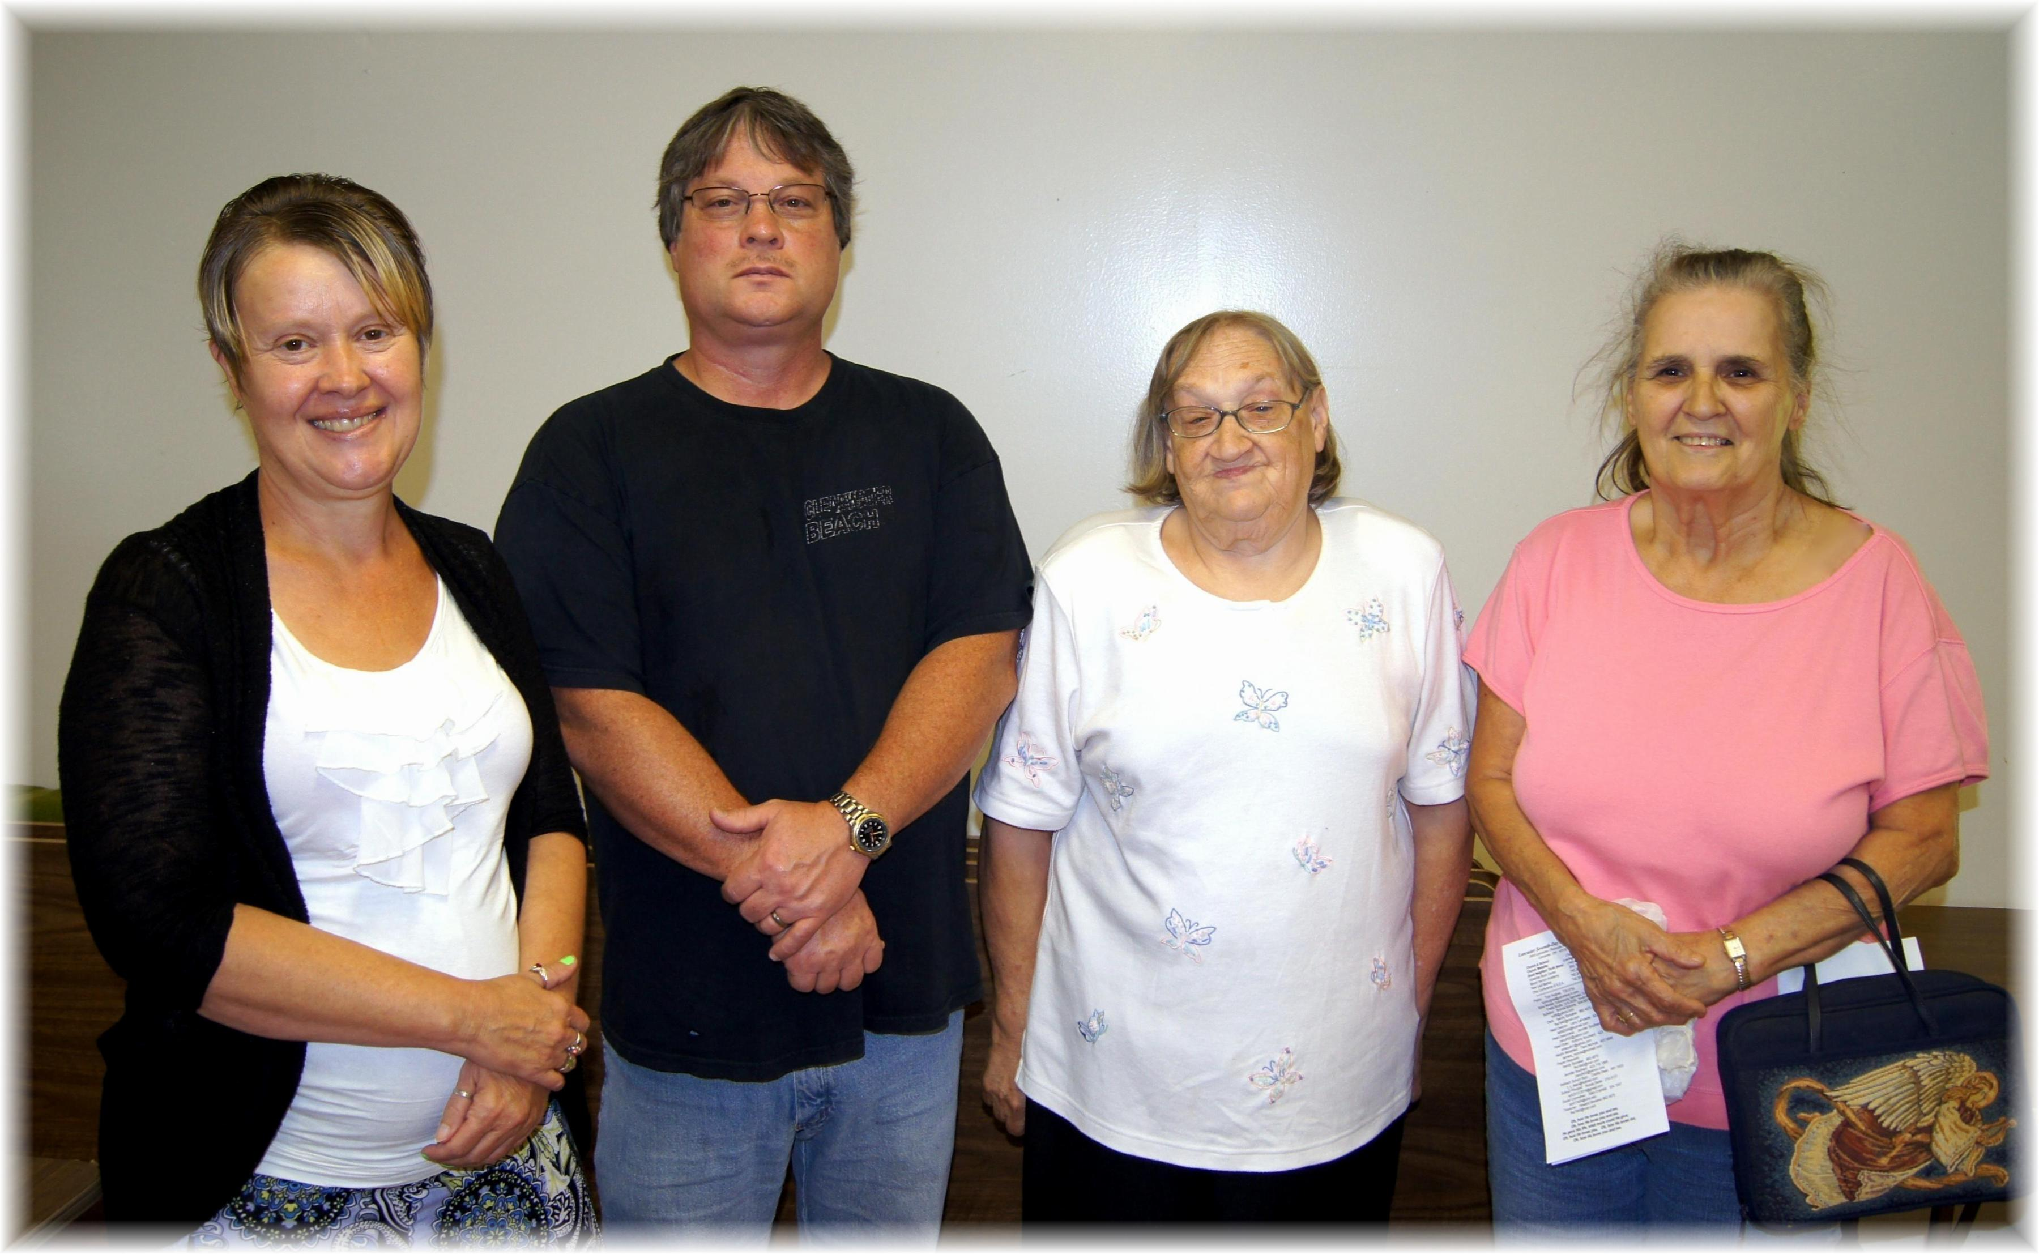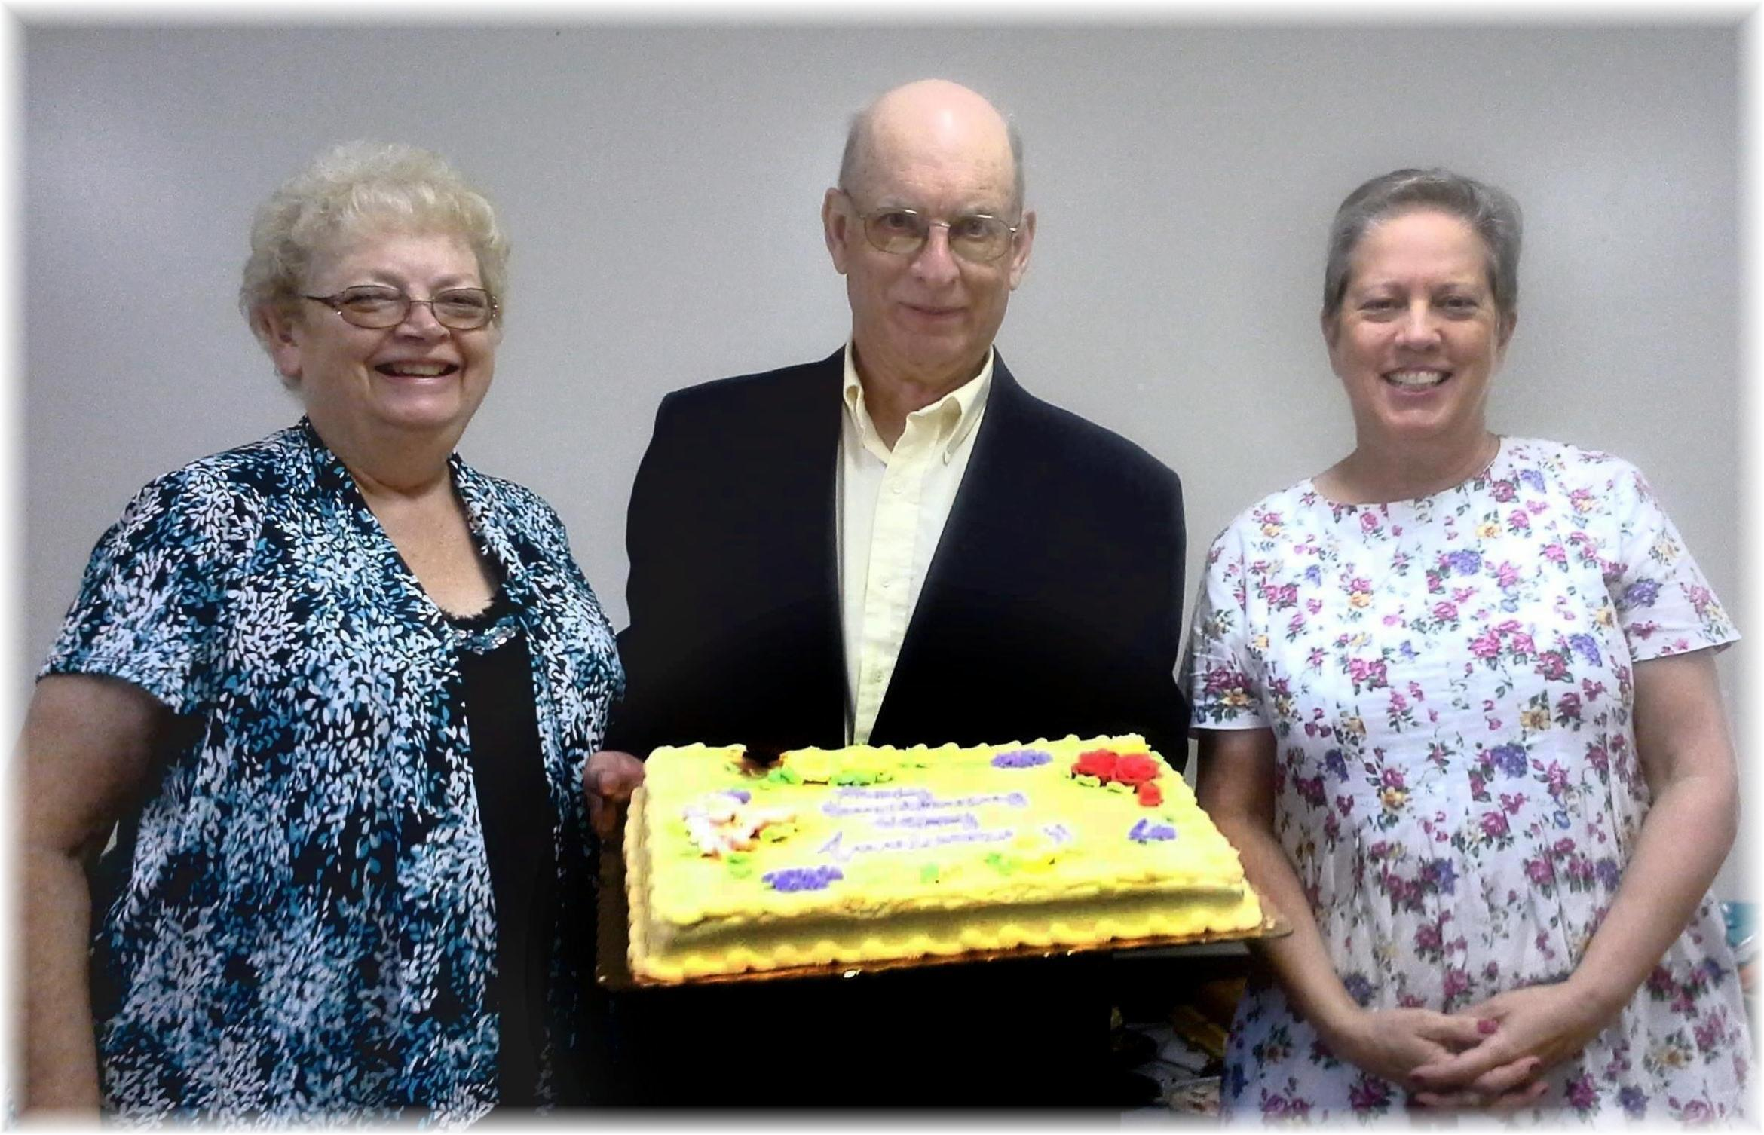

Birthdays: Deena, Jim, Linda, Karen Anniversaries: Sandy & Howard, Geri
August Birthdays and Anniversaries - 2014

