Lancaster Seventh-Day Adventist Church
A House of Prayer for All People
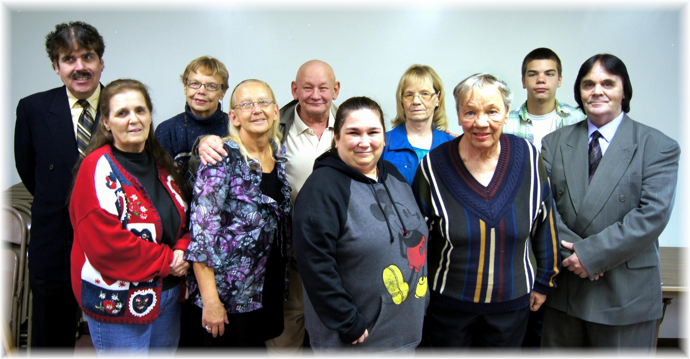
Back Row: Carlton DeNune, Barbara Dorwort , George Brooke, Peggy Selby, Jacob Marcum
Front Row: Karen Hartshorn, Christy Moore, Rhonda Dennison, Marjorie Willis, George Fields
October Baptisms - 2014

