Lancaster
Seventh-Day Adventist Church
A House of Prayer for All People

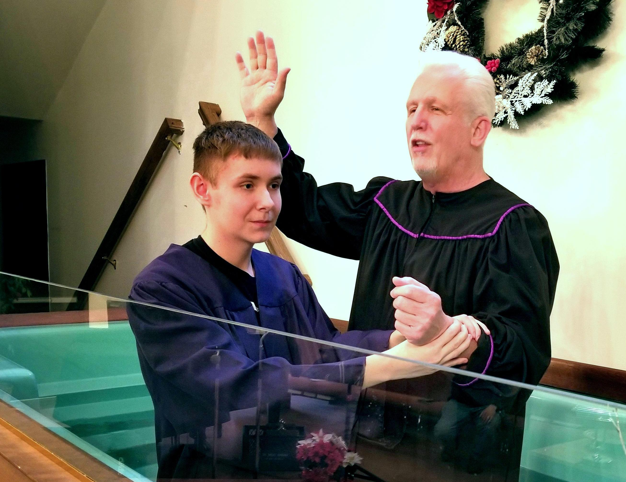

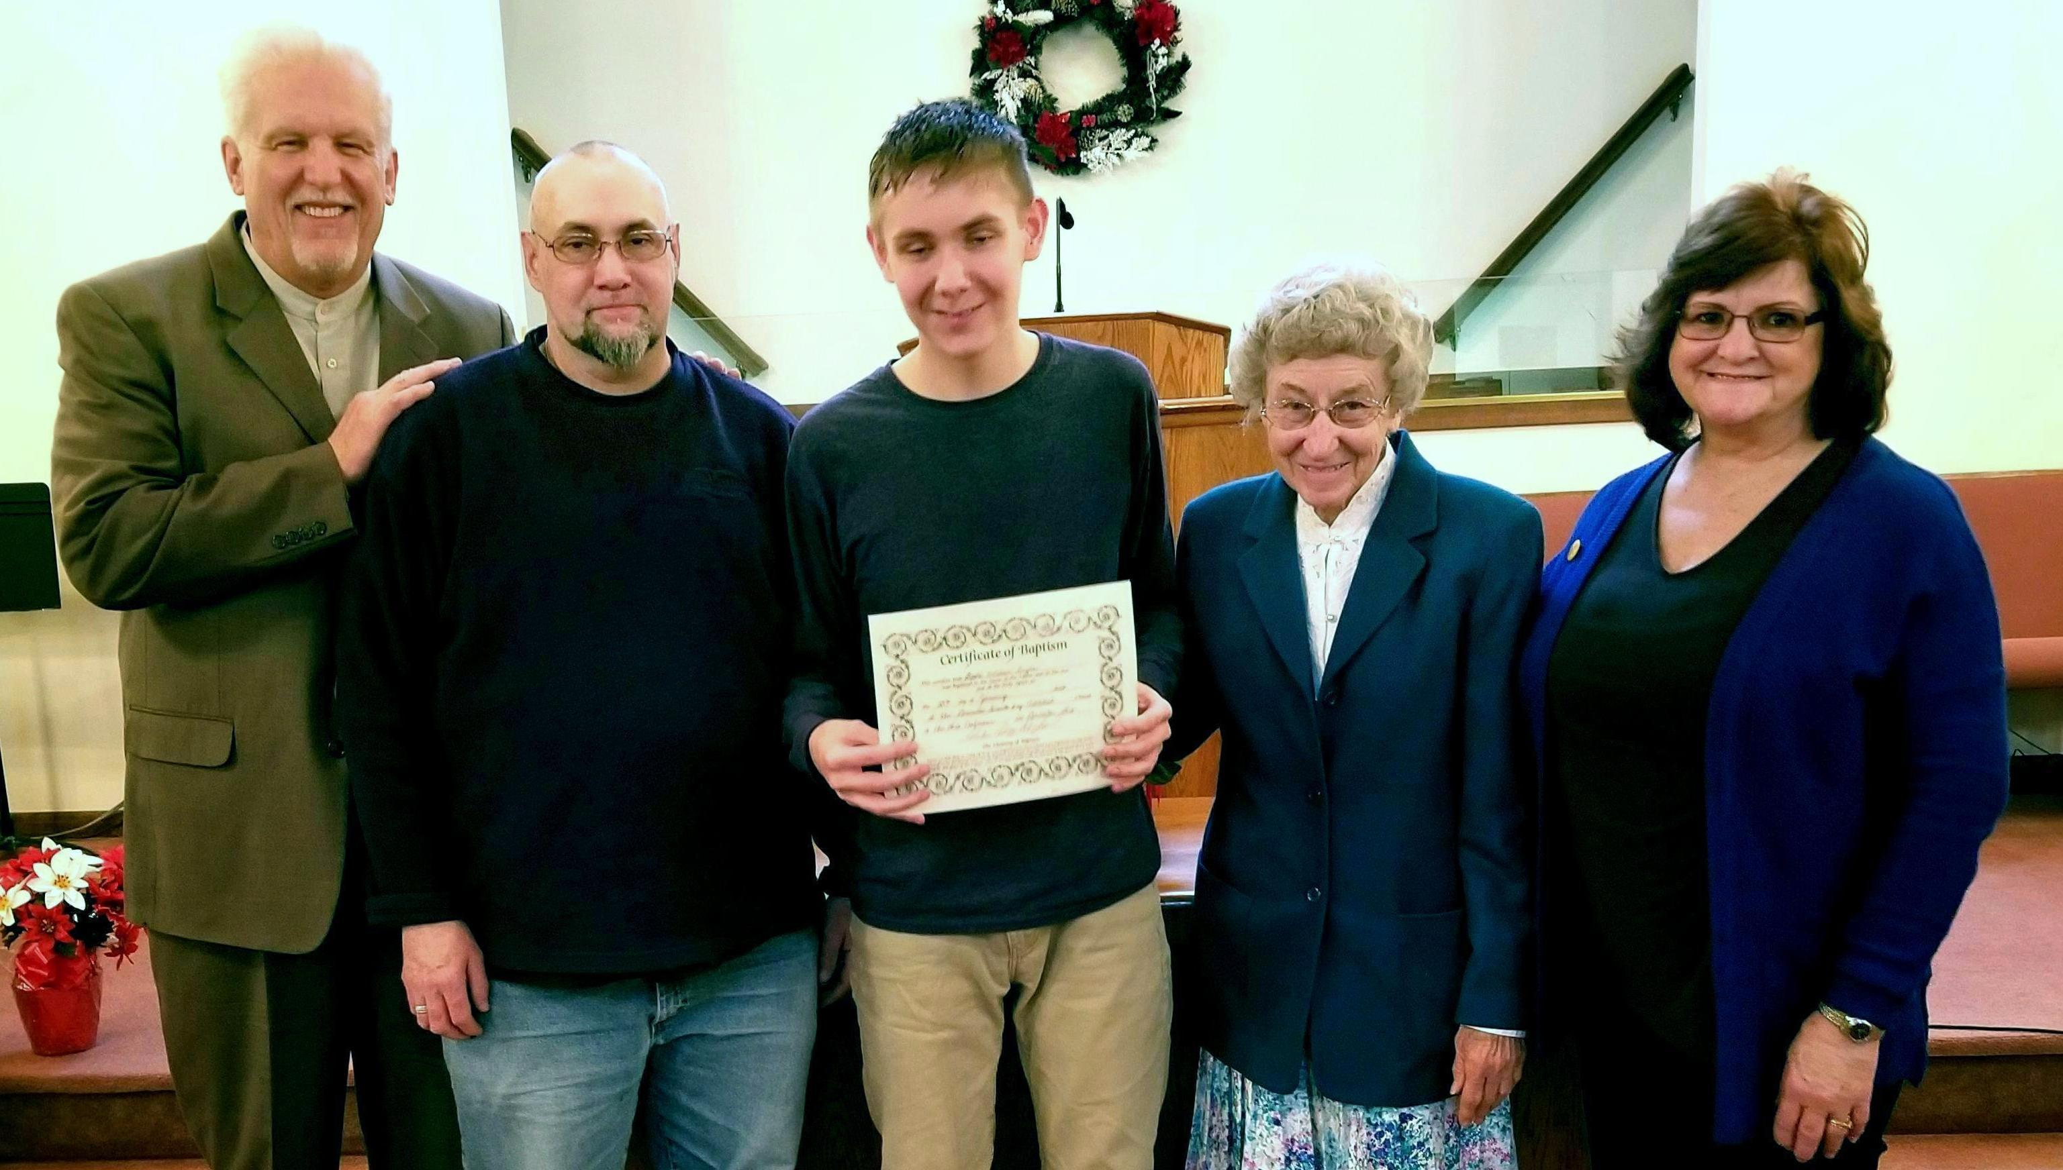
Pastor Tom, Rob, David, Freda, Linda
David Snyder Baptism – January 27, 2018

