Lancaster Seventh-Day Adventist Church
A House of Prayer for All People

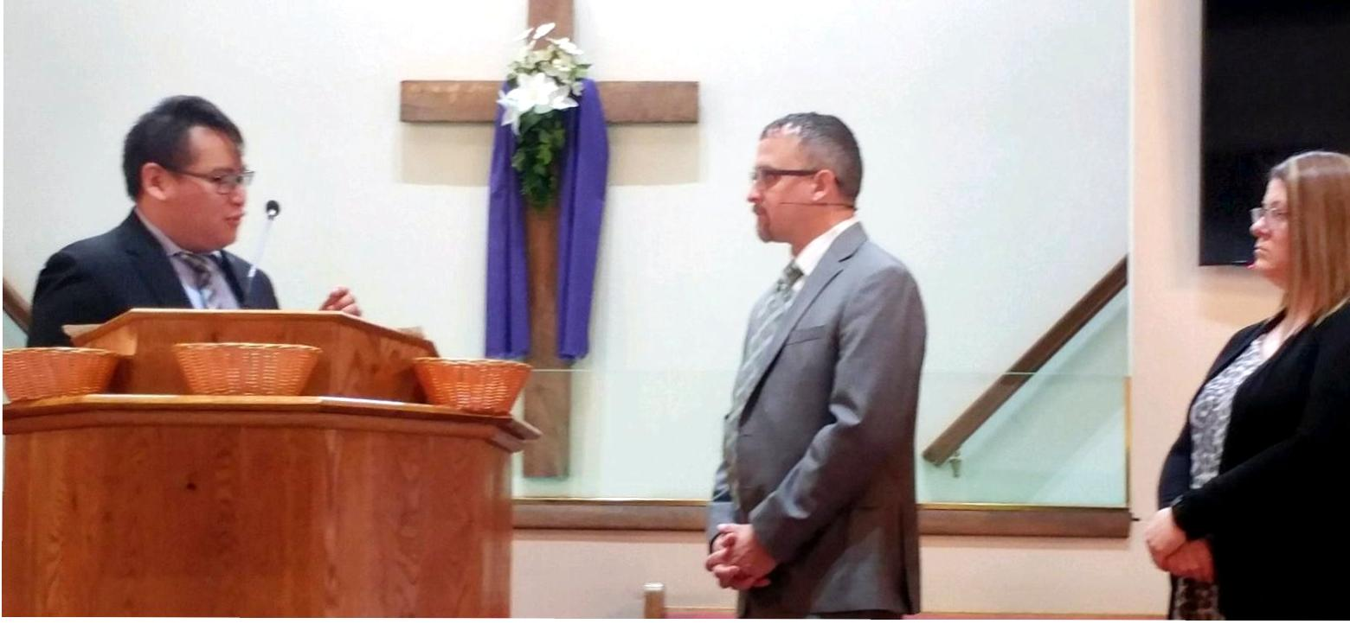
Jeremy Wong Jonathon Hinkle
Elder Ordination – 1-29-22

