Lancaster Seventh-Day Adventist Church
A House of Prayer for All People

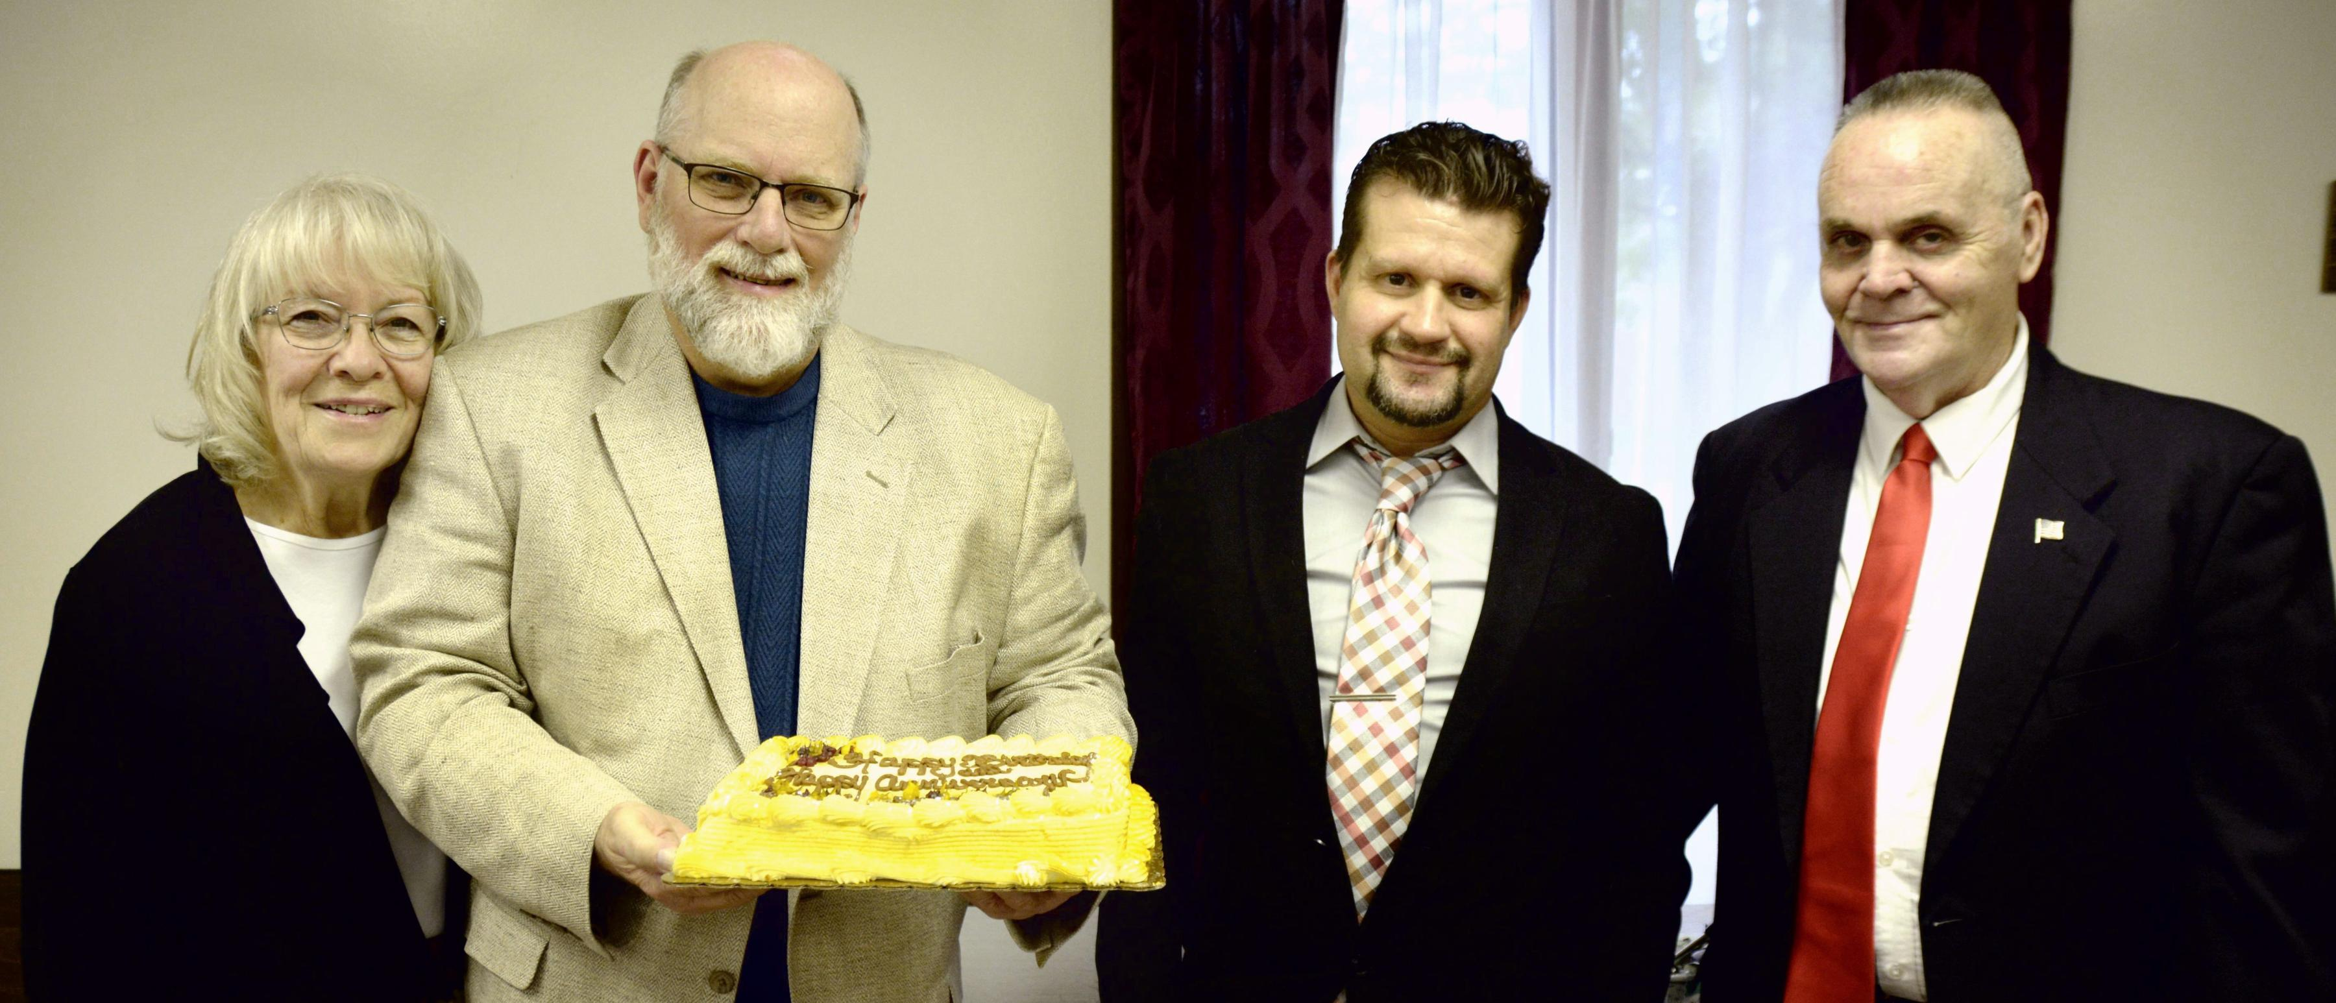
Anniversary: Donna & Eldon Birthdays: Allen, George
September Anniversary and Birthdays ~ 2021

