Lancaster Seventh-Day Adventist Church
A House of Prayer for All People

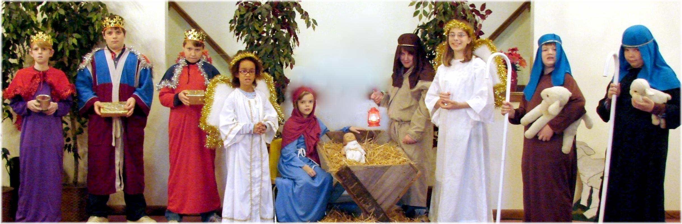
Church School Christmas Program - December 12, 2009

