Lancaster Seventh-Day Adventist Church
A House of Prayer for All People

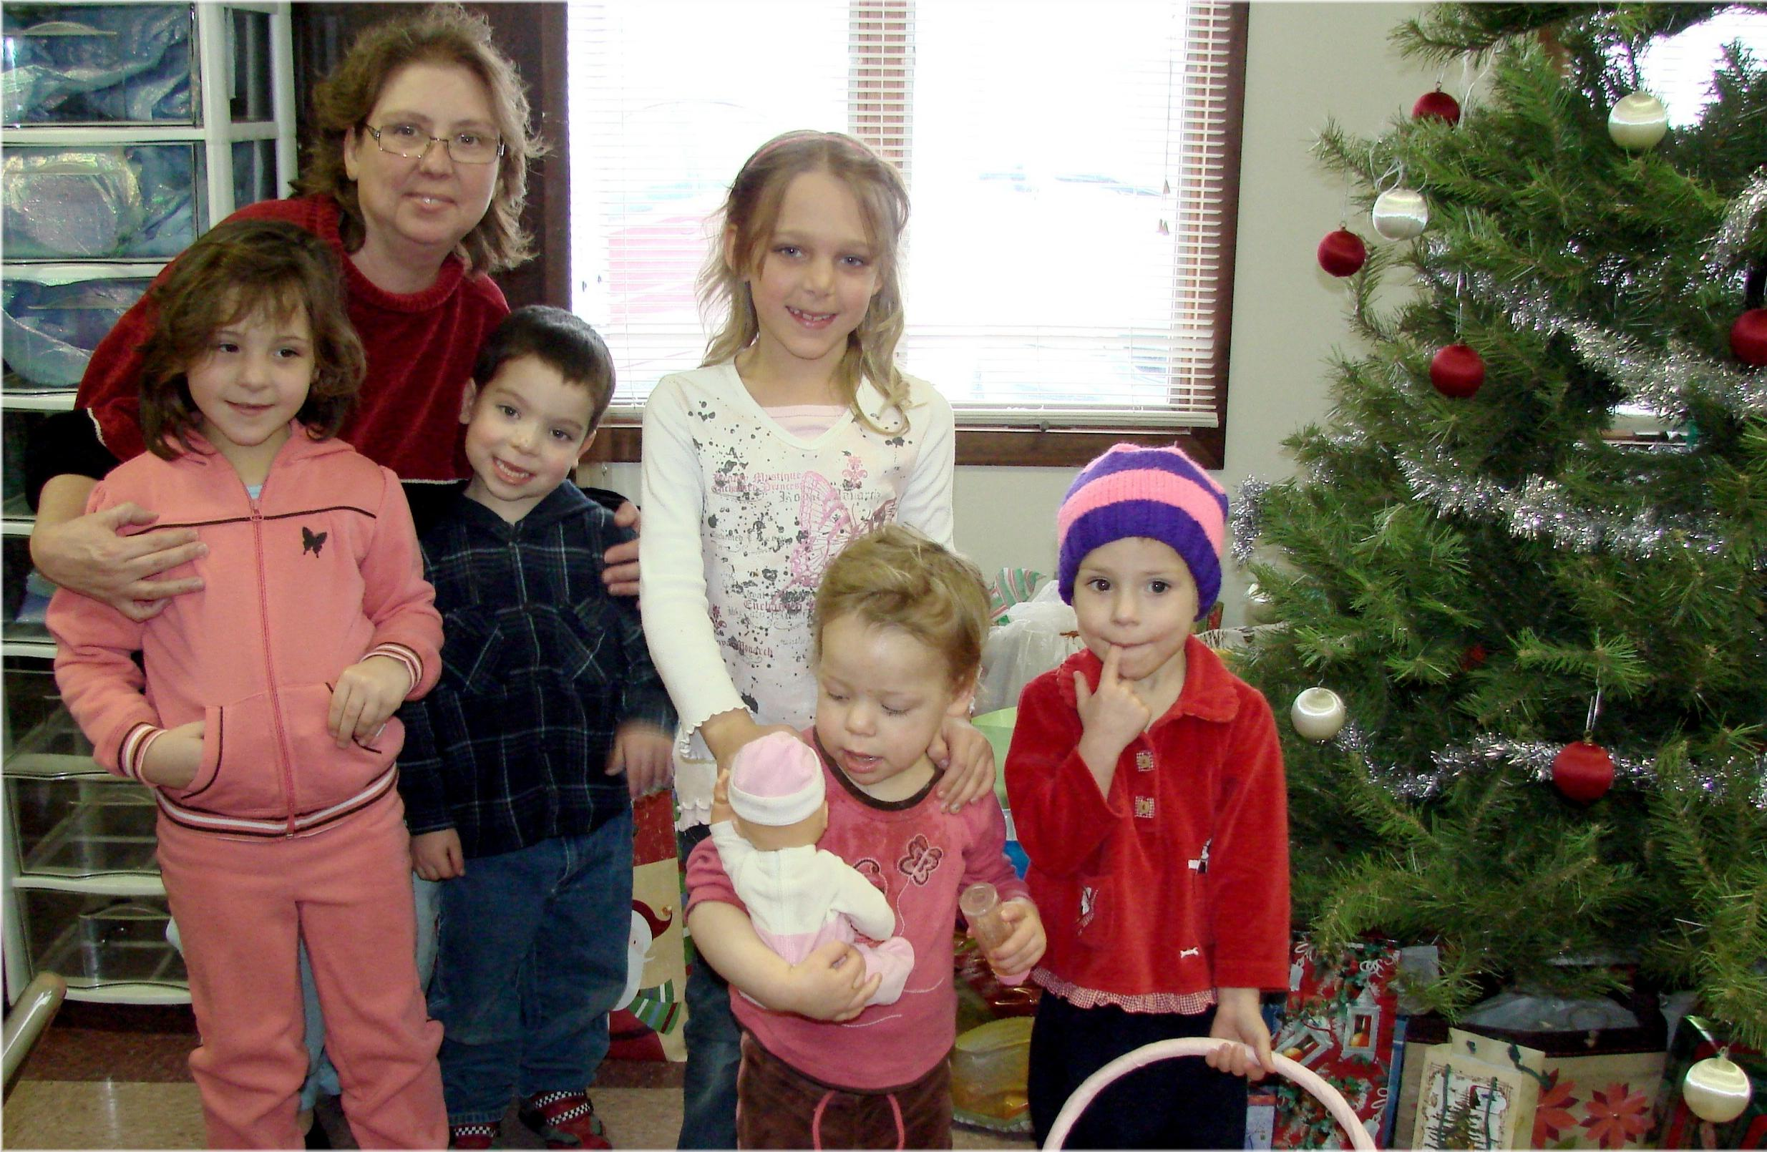
Our Christmas Family - 2009

