Lancaster Seventh-Day Adventist Church
A House of Prayer for All People

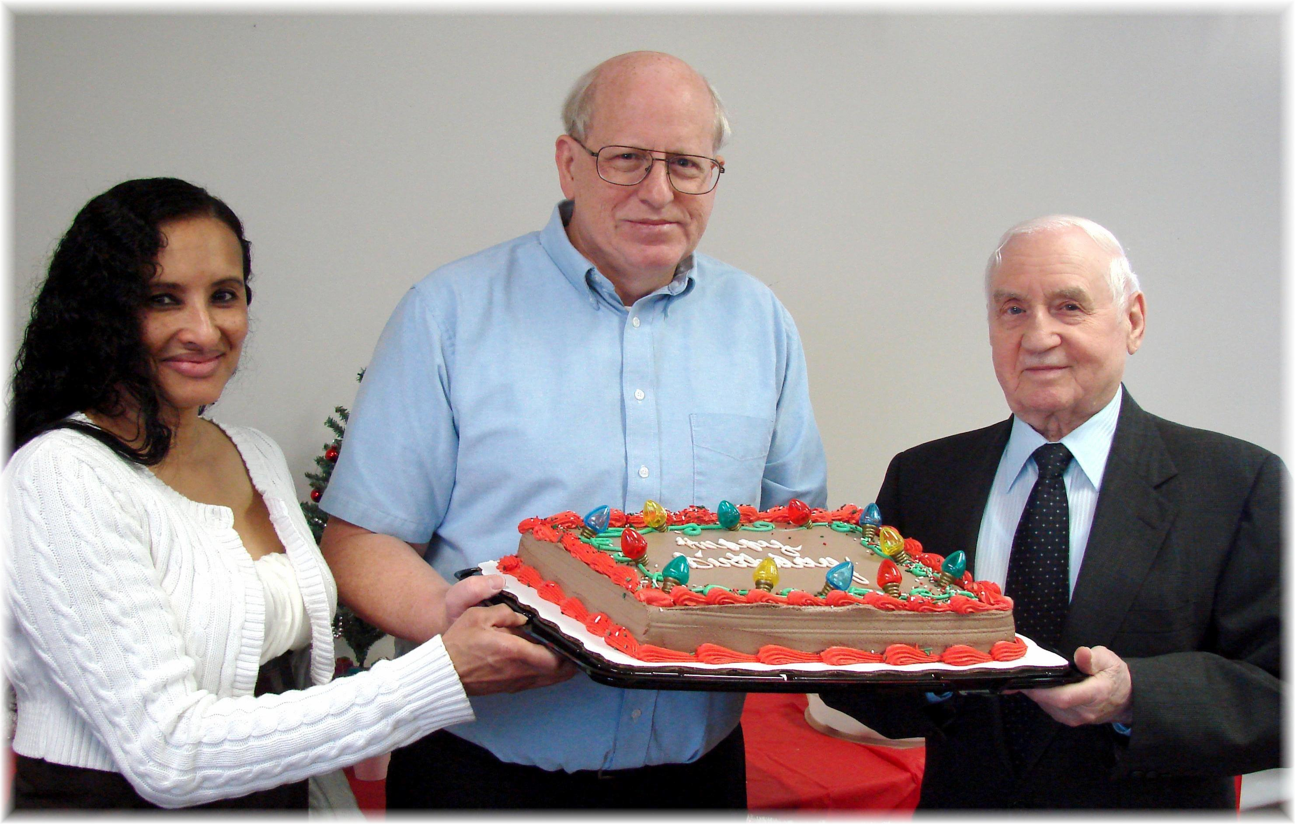
Beverly, Bill, Al
December Birthdays - 2010

