Lancaster Seventh-Day Adventist Church
A House of Prayer for All People

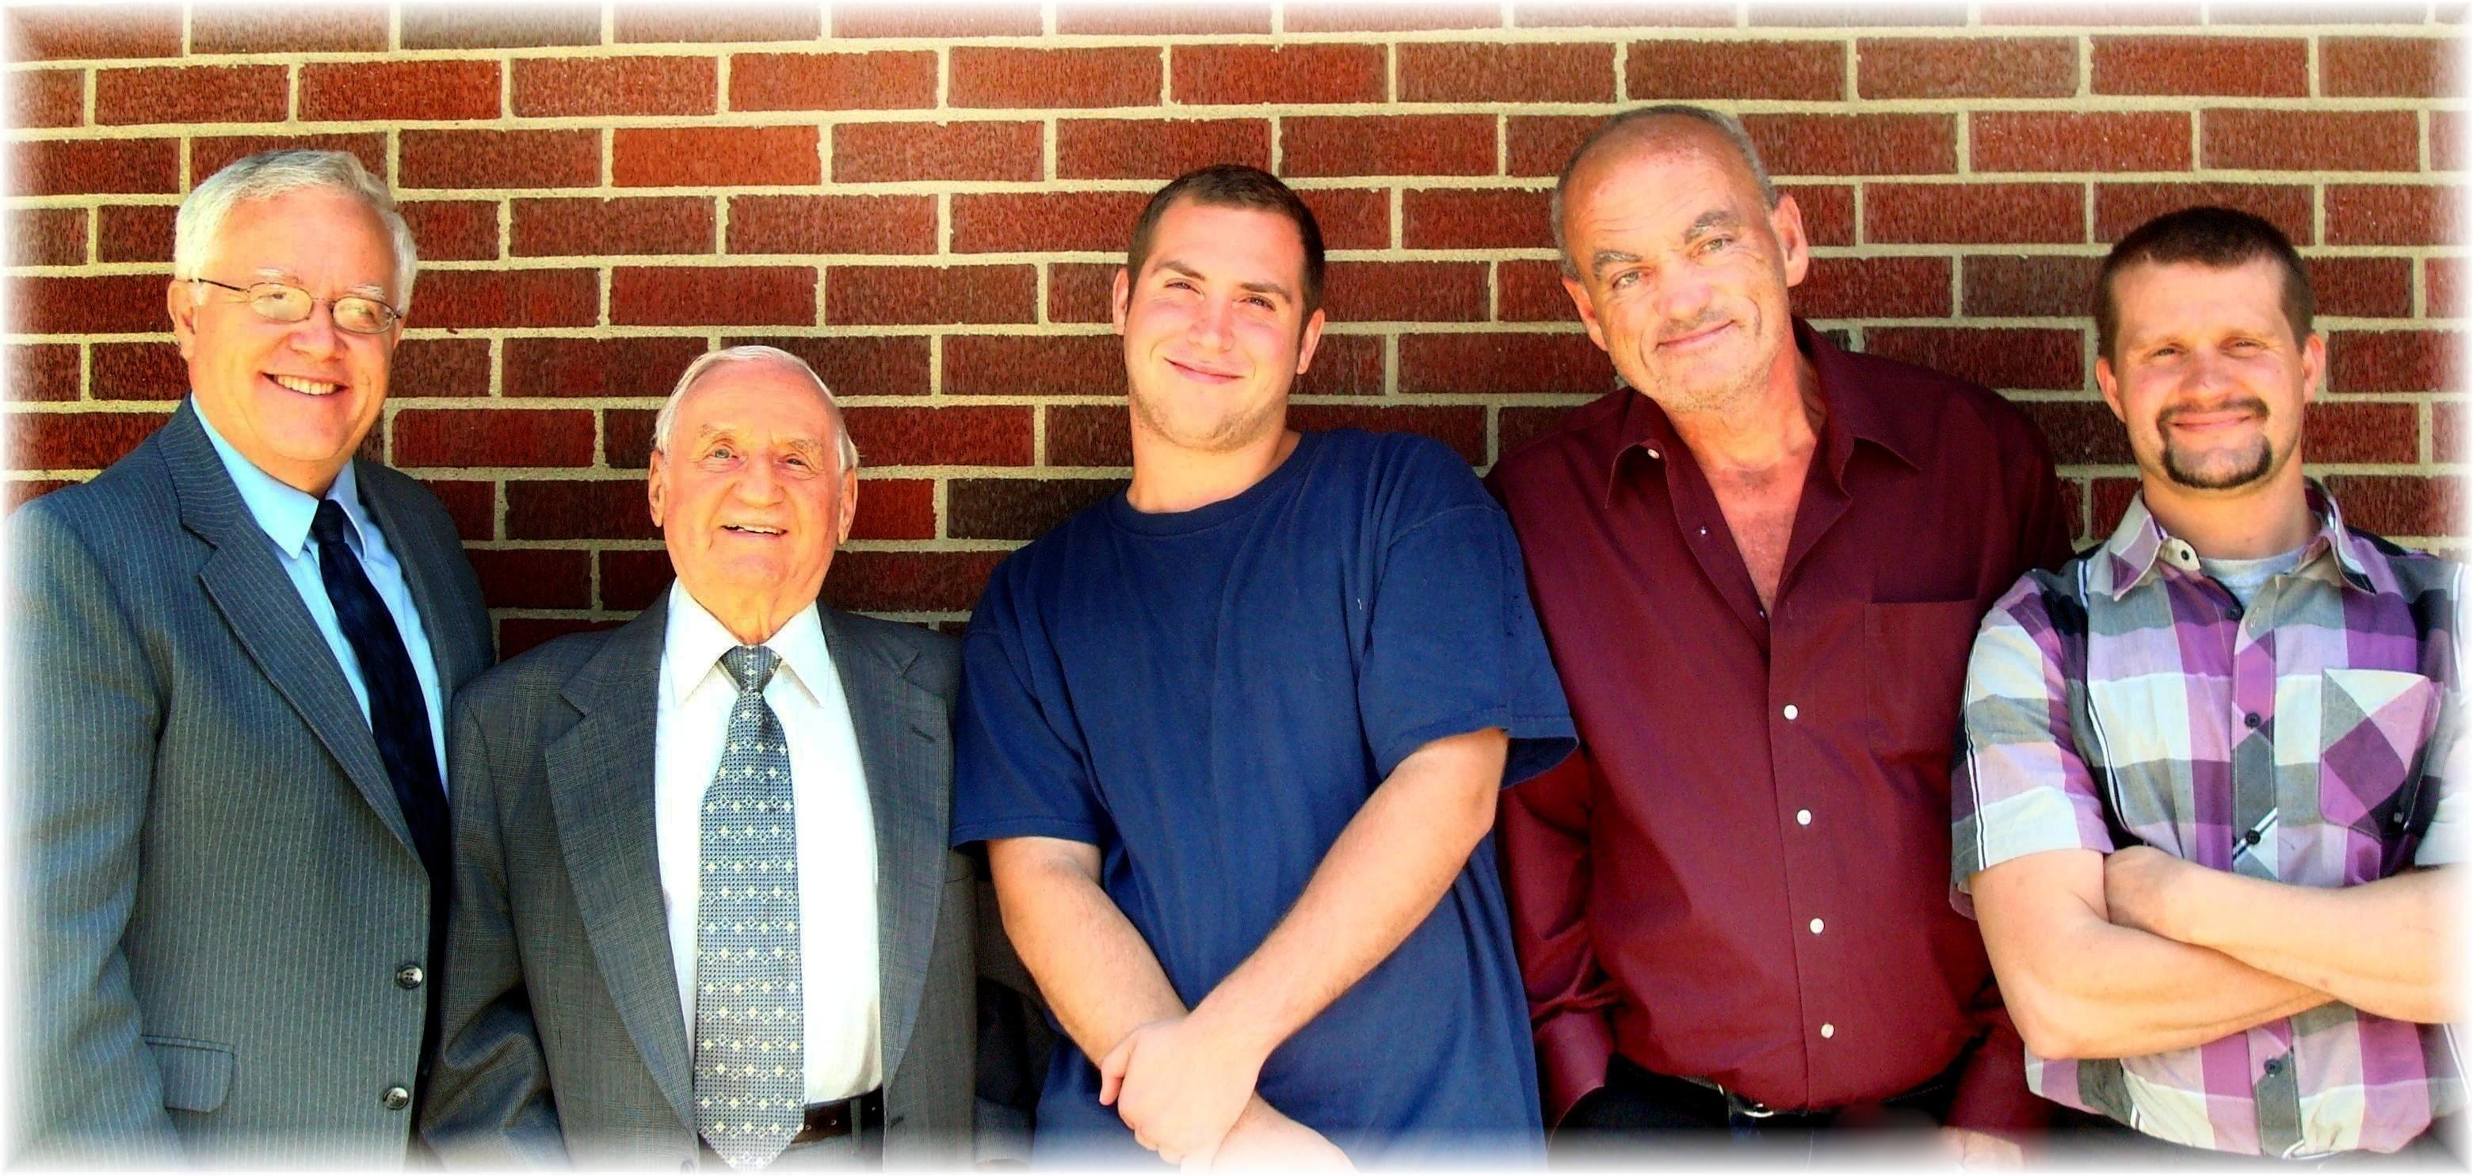
Al Al Alan Allen Allen

