Lancaster Seventh-Day Adventist Church
A House of Prayer for All People

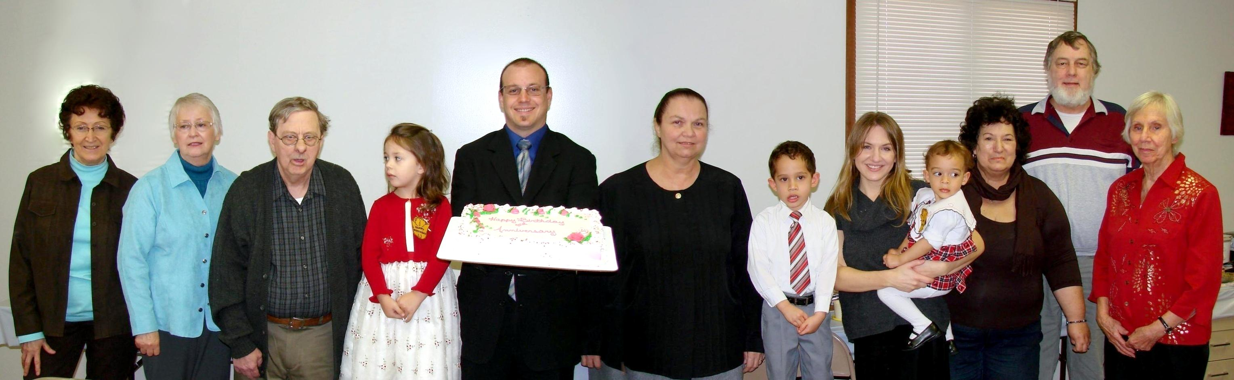

Birthdays: Alice, Sharon, David, Callie, Anthony, Debby, Elijah, Trina, Abigail
Anniversaries: Kay & Mike, Betty
February Birthdays and Anniversaries - 2011

