Lancaster Seventh-Day Adventist Church
A House of Prayer for All People

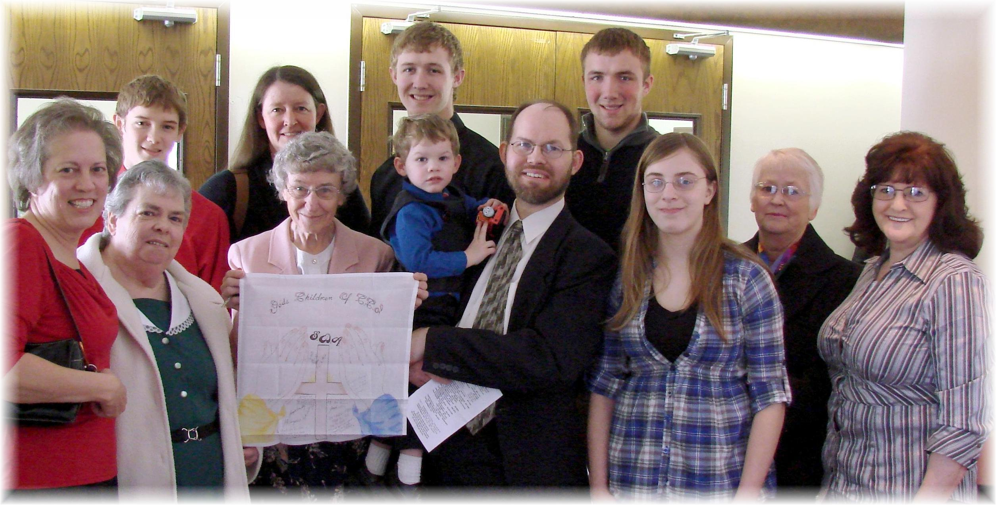

Greeting Our Friends in Prison – March 2011

