Lancaster Seventh-Day Adventist Church
A House of Prayer for All People

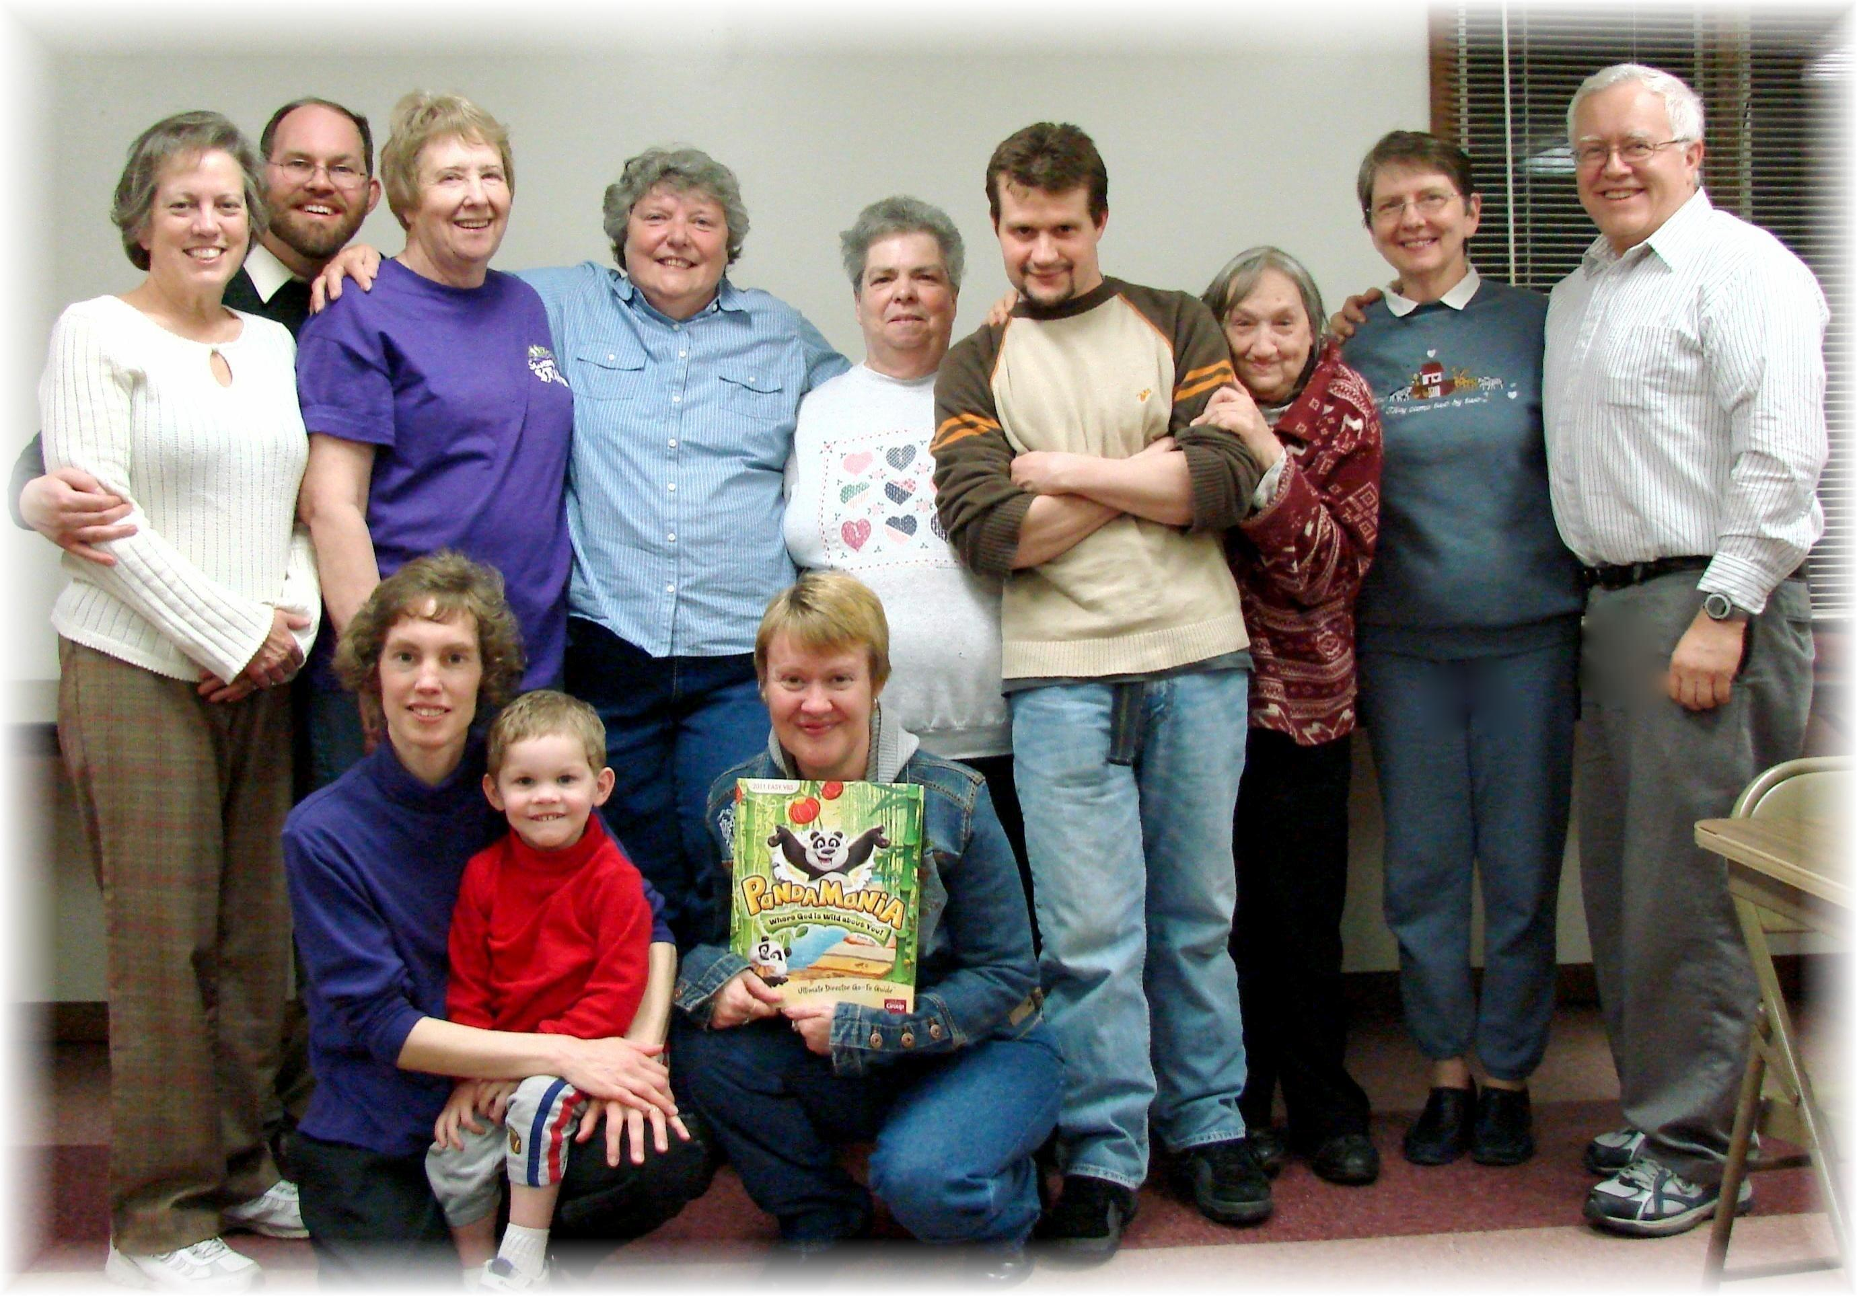
PandaMania Vacation Bible School – 1st Planning Session – 4-16-11

