Lancaster Seventh-Day Adventist Church
A House of Prayer for All People
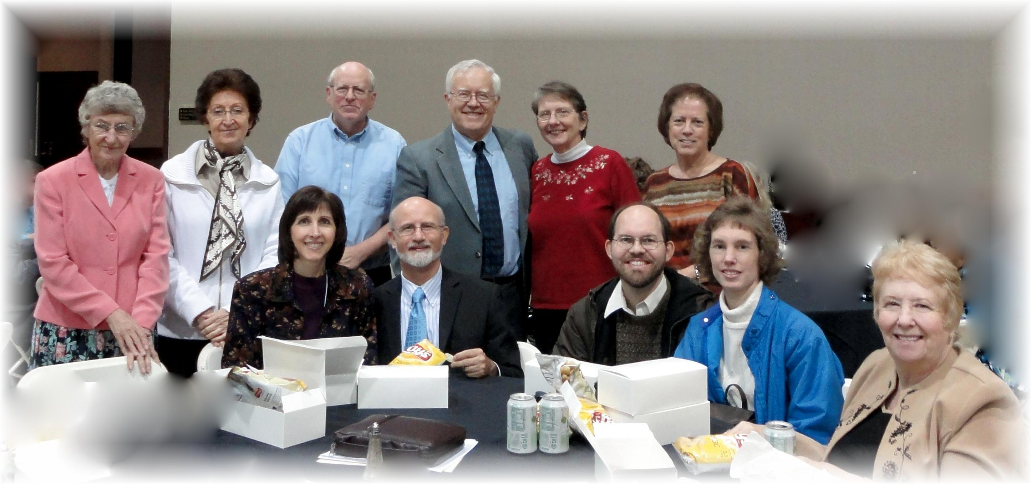

Back Row: Freda, Alice, Bill, Al, Bonnie, Geri
Front Row: Nancy, Pastor Mike, James, Connie, Diane
Acts ’11 – Wilmington, OH - October 22, 2011

