Lancaster Seventh-Day Adventist Church
A House of Prayer for All People

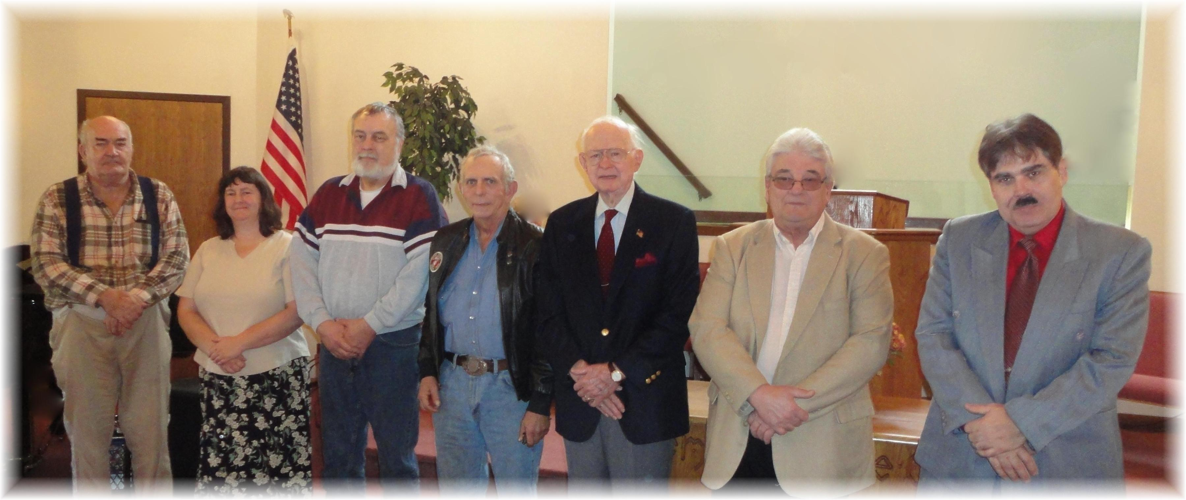
We thank you for your service: Harry, Kim, Mike, John, Ralph, John, Carlton
Veterans’ Day - 2011

