Lancaster Seventh-Day Adventist Church
A House of Prayer for All People

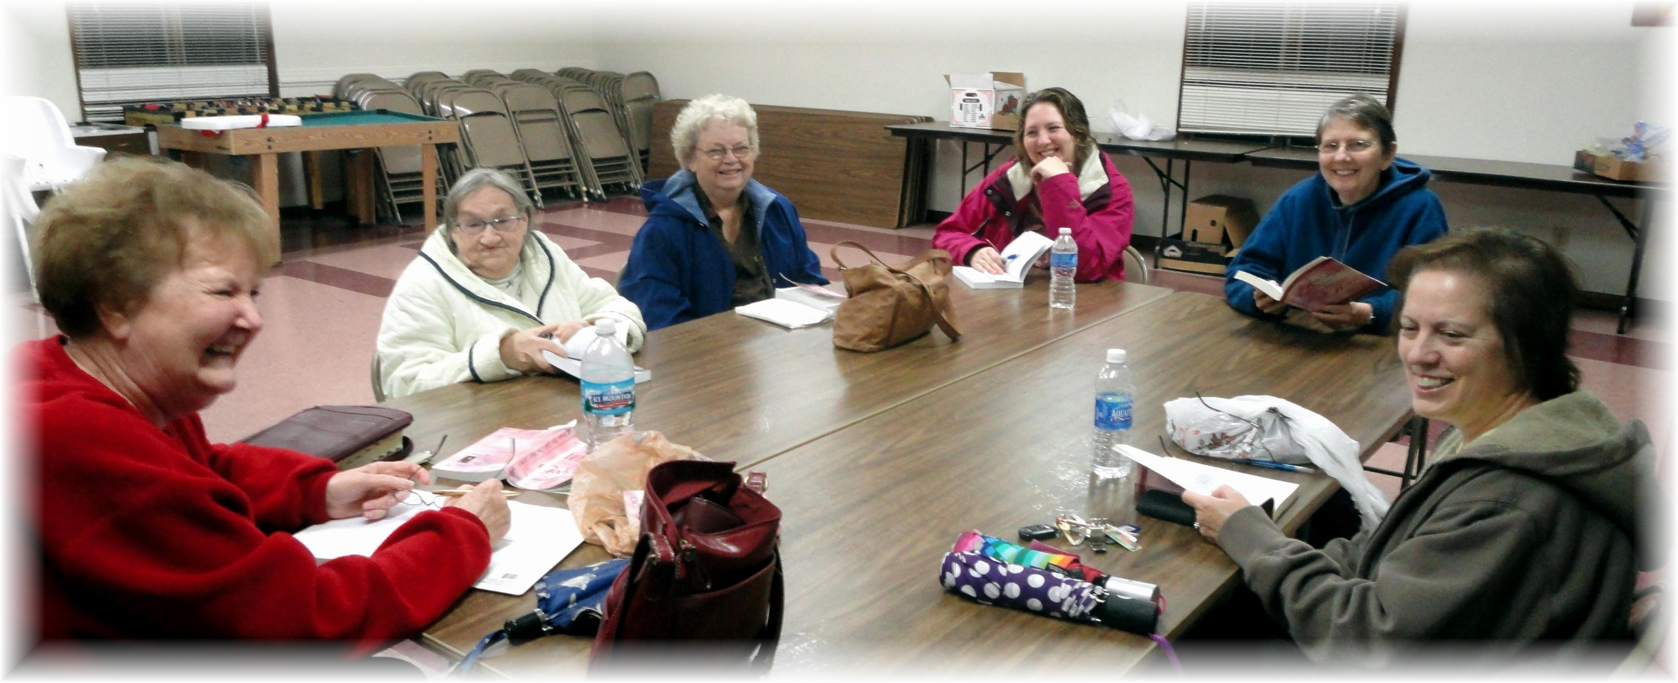
Linda J., Linda M., Sandy, Jennifer, Bonnie, Geri
Proverbs 31 Ladies Meeting - 2012

