Lancaster Seventh-Day Adventist Church
A House of Prayer for All People

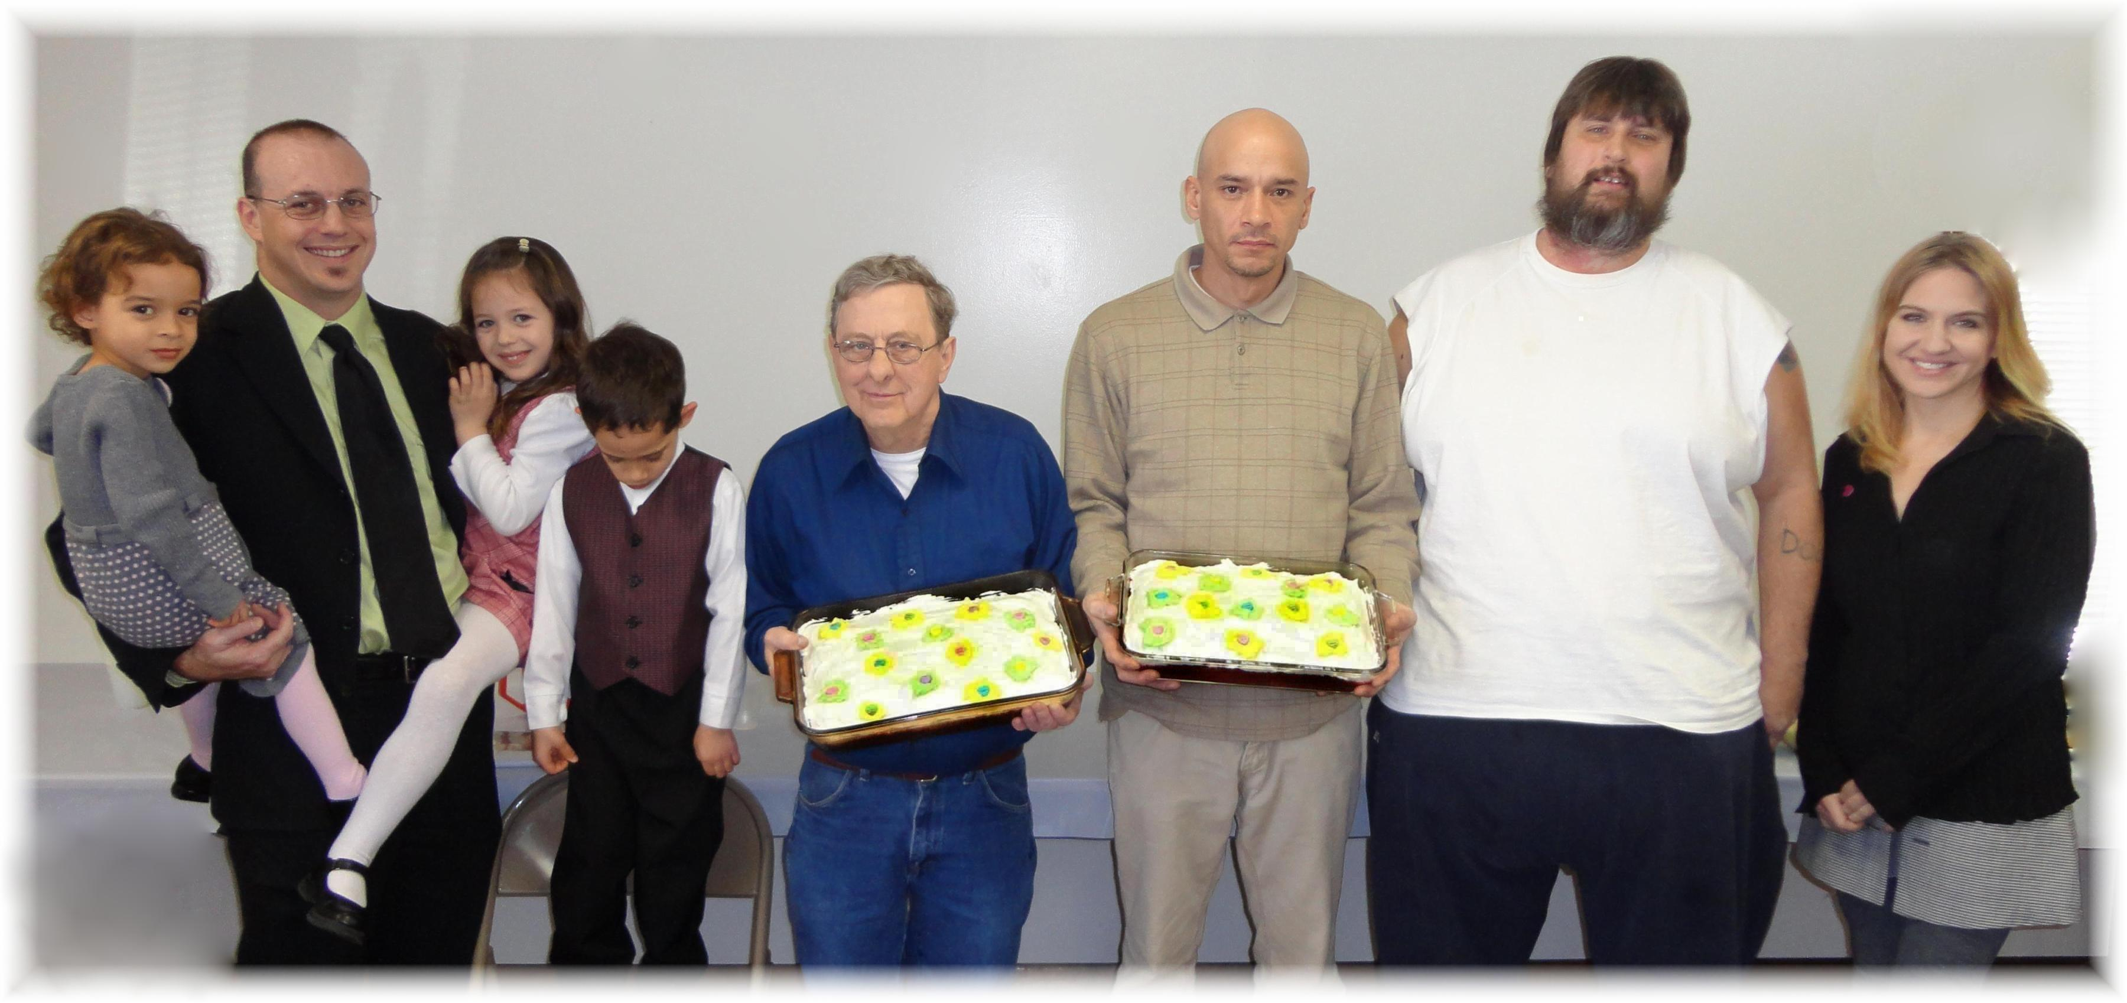
Abigail, Anthony, Callie, Elijah, David, Jason, Willy, Trina
February Birthdays - 2012

