Lancaster Seventh-Day Adventist Church
A House of Prayer for All People

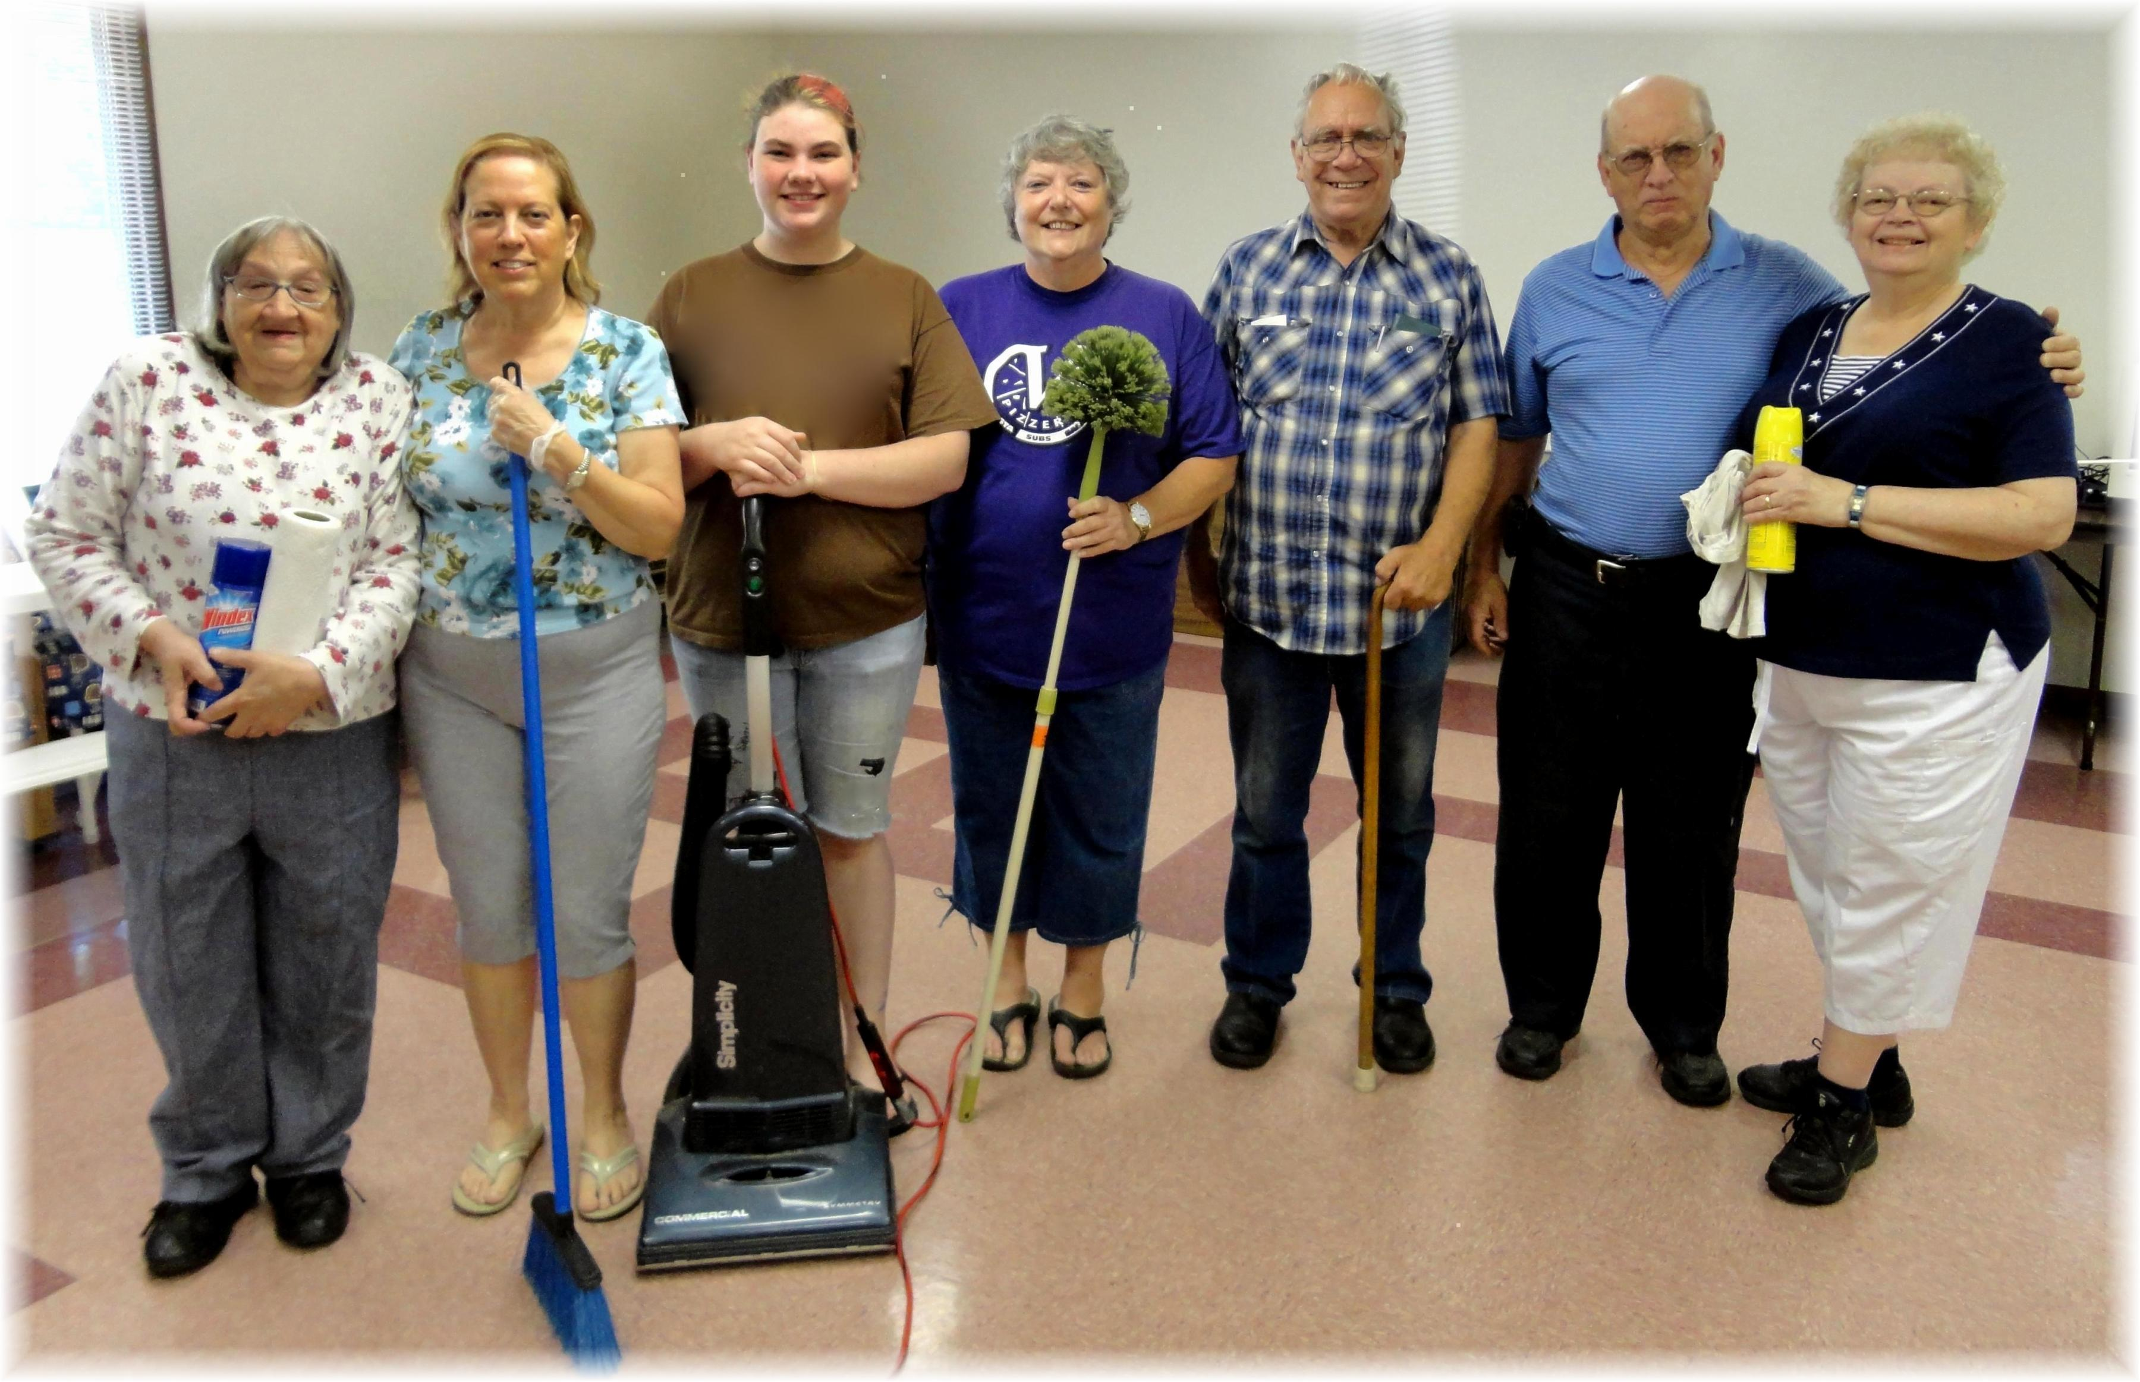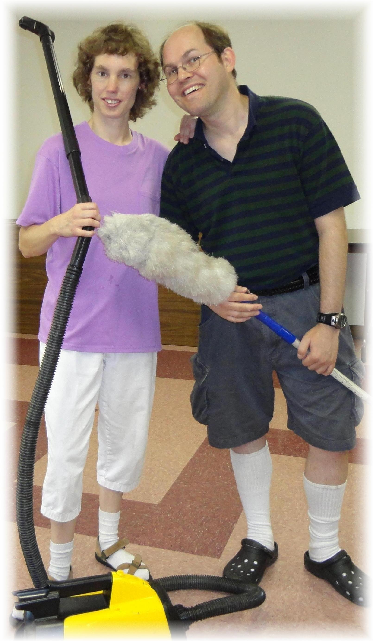
Linda, Geri, Mickey, Nadean, Tom, Howard & Sandy Connie & James
Church Cleaning Crew – 2012

