Lancaster Seventh-Day Adventist Church
A House of Prayer for All People

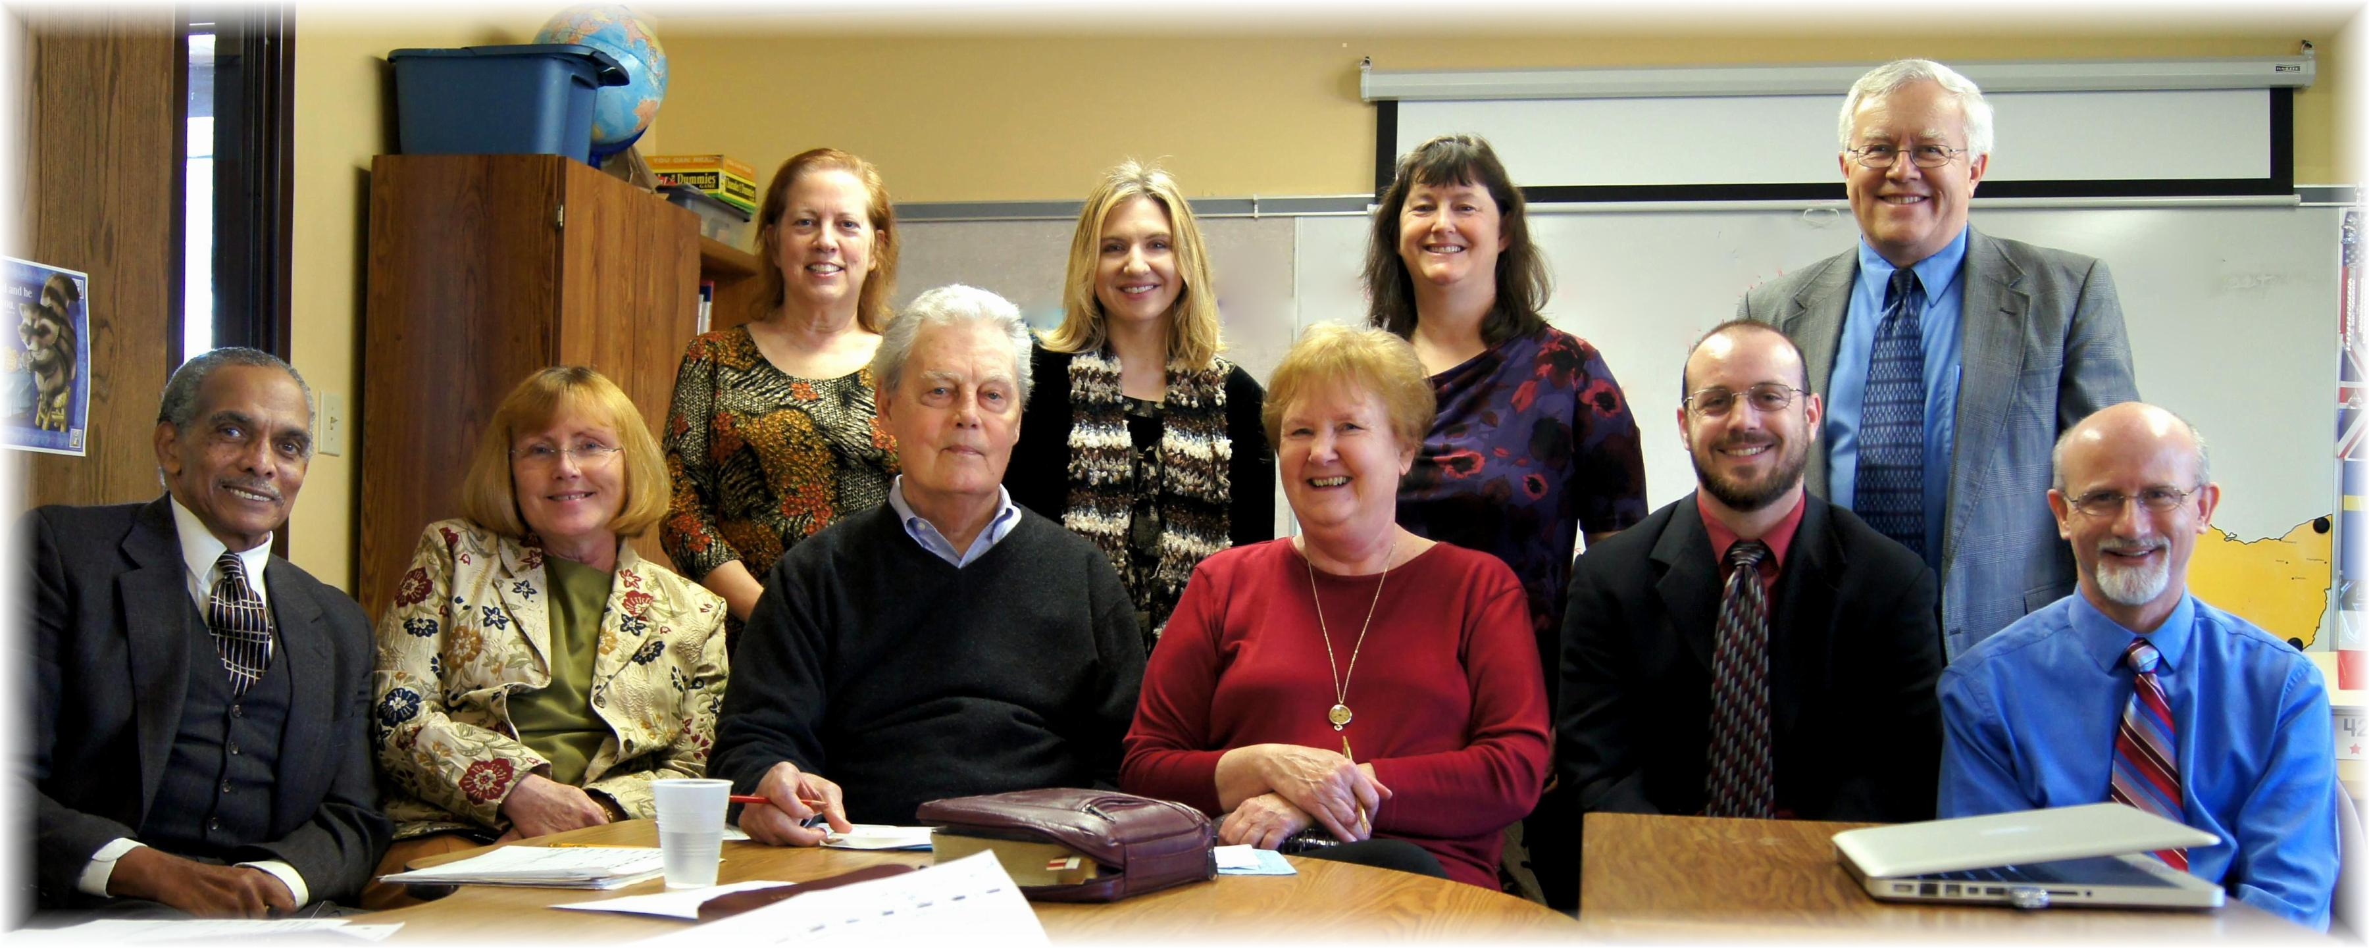
Back Row: Geri, Trina, Kim, Al
Front Row: Rick, Christine, Bob, Linda, Anthony, Pastor Mike
Worship Team – February 2013

