Lancaster Seventh-Day Adventist Church
A House of Prayer for All People

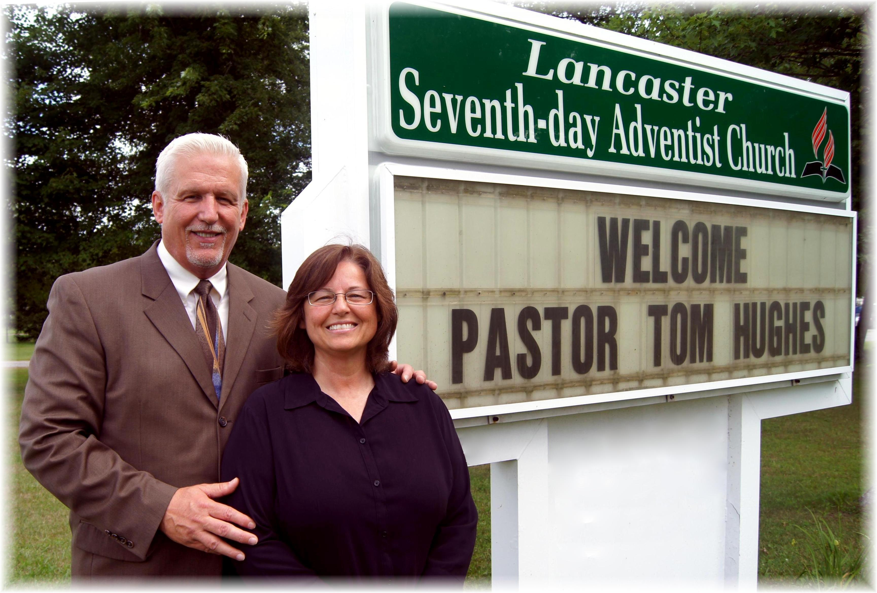
Welcome: Pastor Tom & Debbie Hughes – July 6, 2013

