Lancaster Seventh-Day Adventist Church
A House of Prayer for All People

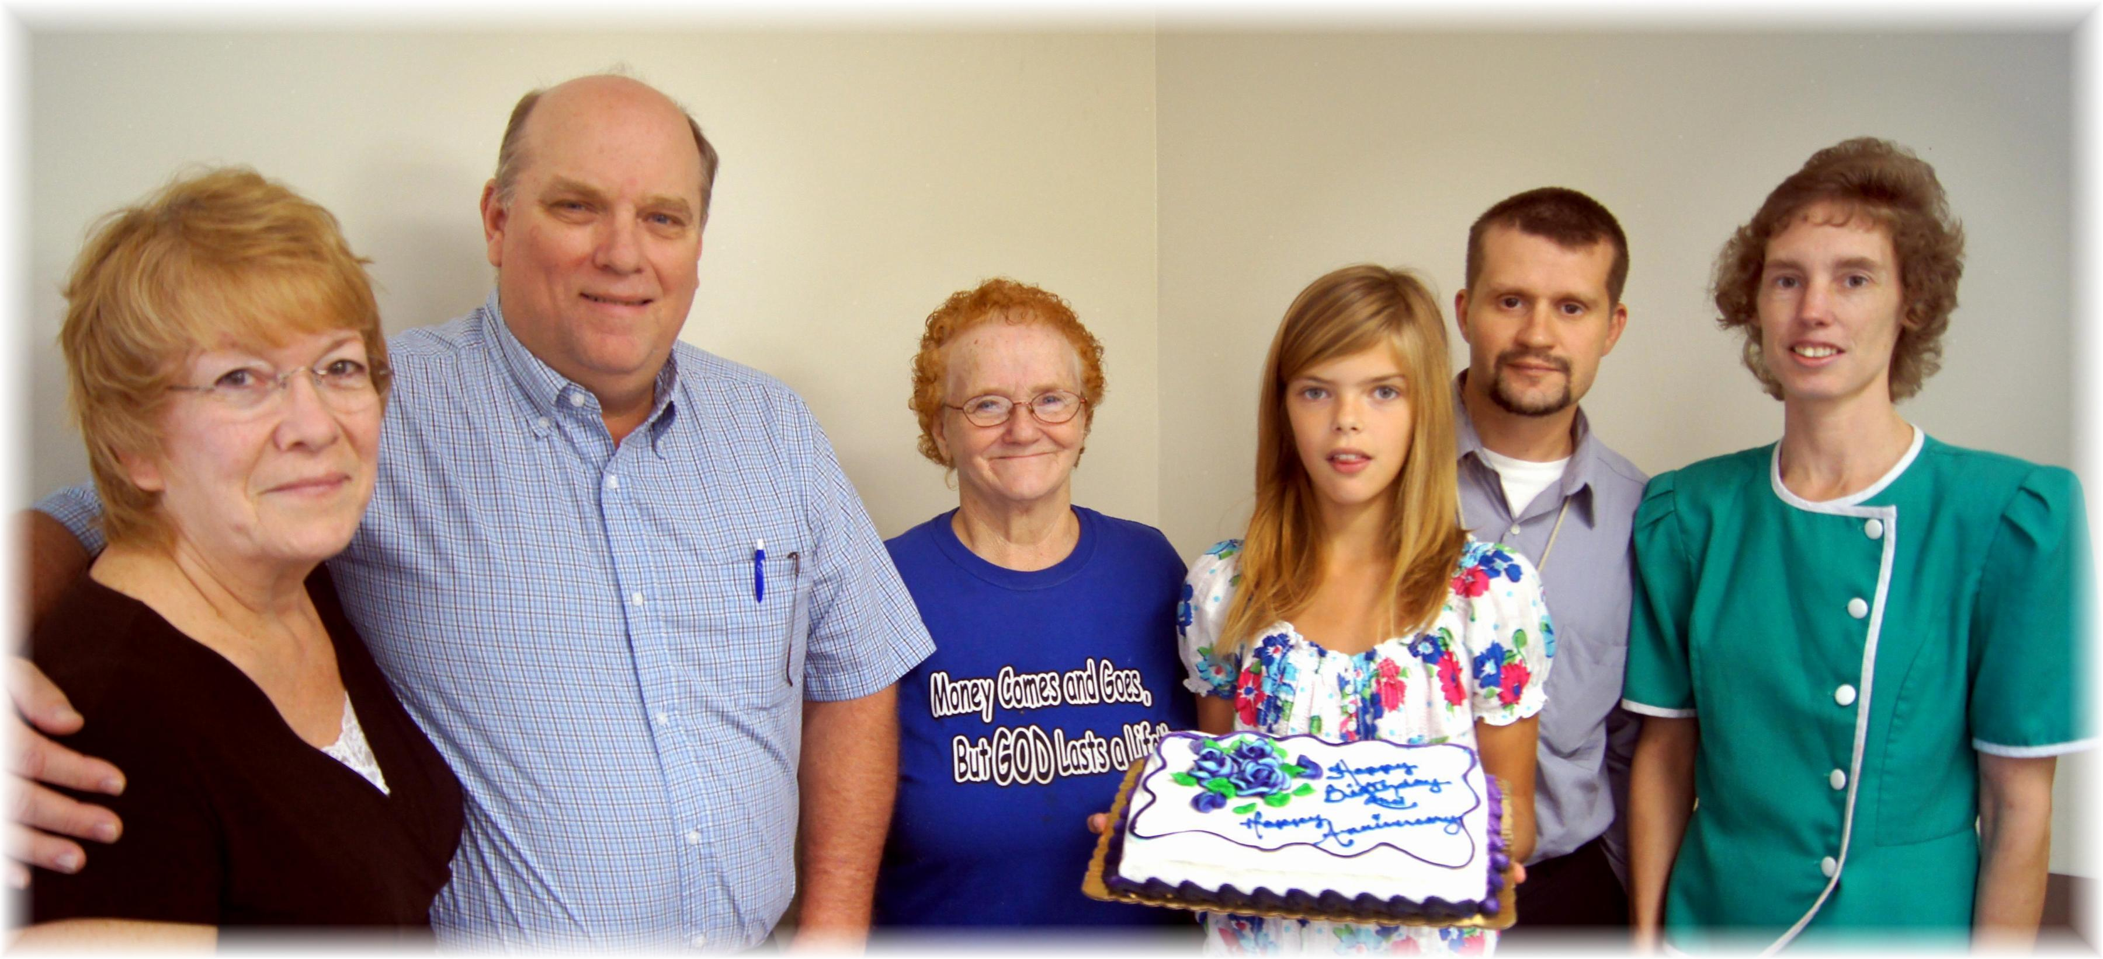
Anniversaries: Donna & Eldon, Sandy Birthdays: Sandy, Tabby, Allen, Connie
September Anniversaries and Birthdays - 2013

