Lancaster Seventh-Day Adventist Church
A House of Prayer for All People

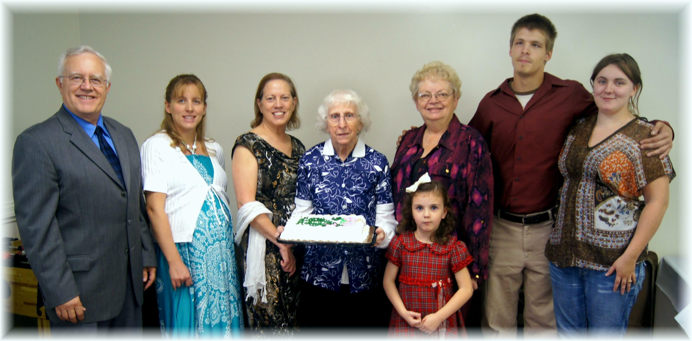
Birthdays: Al, Marijke, Geri, Edith, Alena, Sandy Anniversary: Seth & Shaina
October Birthdays and Anniversary - 2013

