In the Garden
I come to the garden alone
While the dew is still on the roses
And the voice I hear falling on my ear
The Son of God discloses.
And He walks with me, and He talks with me,
And He tells me I am His own;
And the joy we share as we tarry there,
None other has ever known.

The Old Rugged Cross
On a hill far away stood an old rugged cross,
The emblem of suffering and shame;
And I love that old cross where the dearest and best,
For a world of lost sinners was slain.
So I'll cherish the old rugged cross,
Till my trophies at last I lay down,
I will cling to the old rugged cross,
And exchange it someday for a crown.

Amazing Grace
Amazing Grace, how sweet the sound,
That saved a wretch like me!
I once was lost but now am found,
Was blind, but now, I see.
When we've been there ten thousand years
Bright shining as the sun,
We've no less days to sing God's praise
Than when we've first begun.

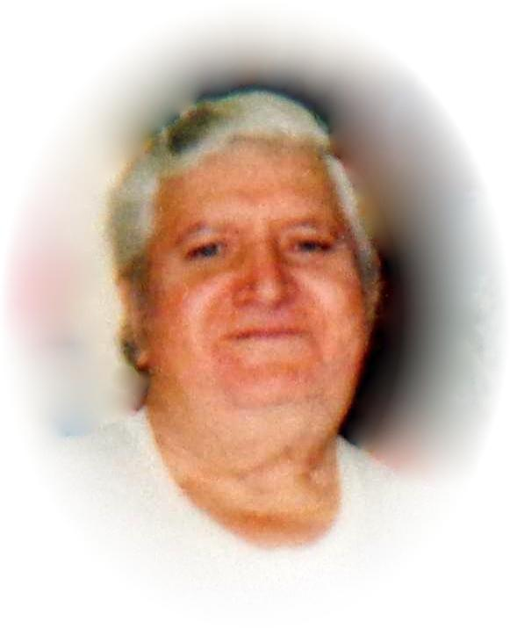
Everette J. Taylor
April 15, 1943 – February 27, 2014

