Lancaster Seventh-Day Adventist Church
A House of Prayer for All People
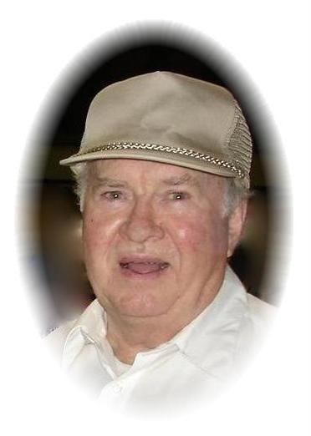
Leon Myers
October 17, 1926 ~~ December 10, 2014

