Lancaster Seventh-Day Adventist Church
A House of Prayer for All People

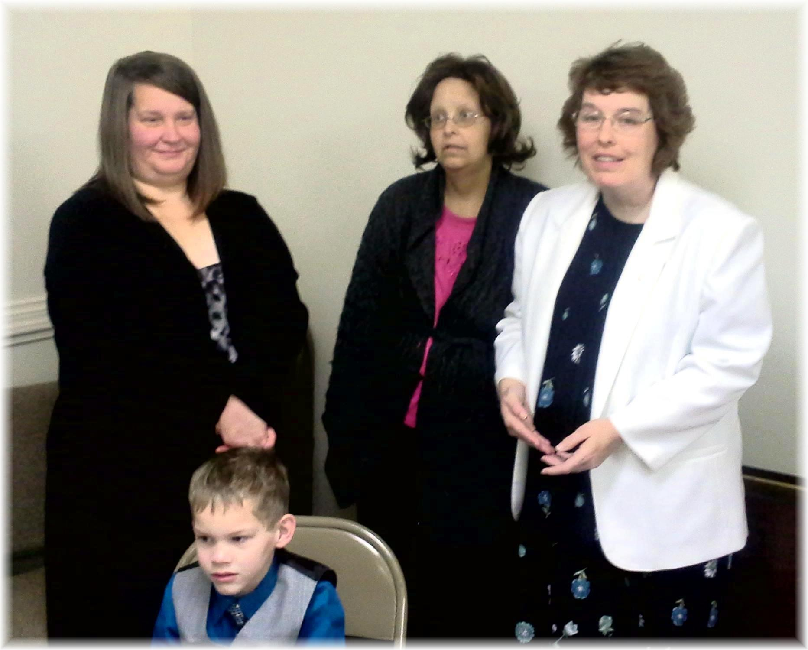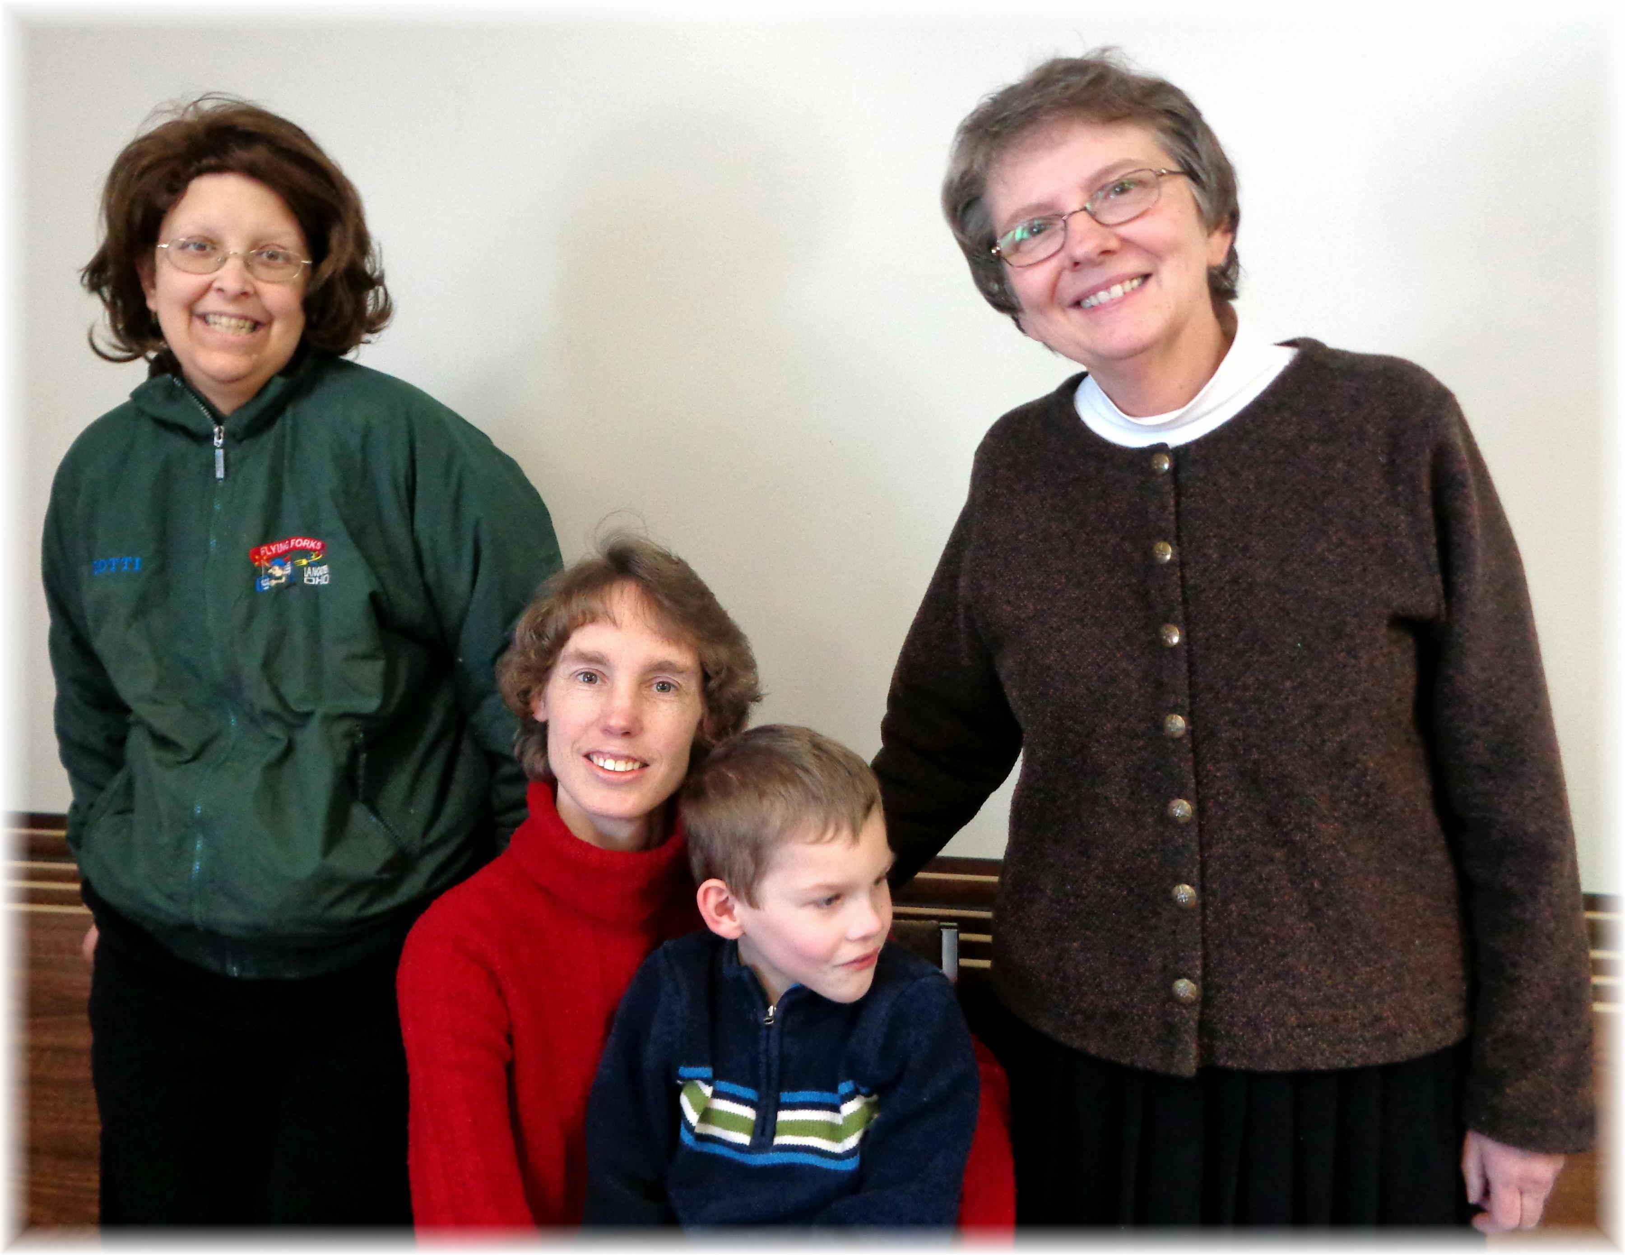
Twila, Andrew, Dotti, Carol Dotti, Andrew (held by Connie), Bonnie
January Birthdays - 2015

